NFOS Newsletter April 2023

Next meeting is

Tuesday April 4th

6 pm in Admin Building

**How to Mount Orchids**

**Pick out one of the lovelies and mount it yourself!**

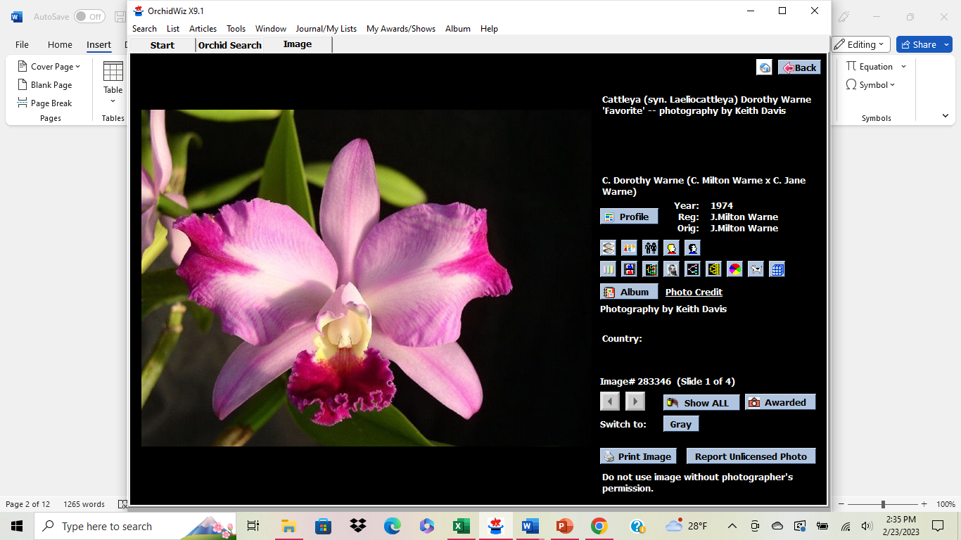 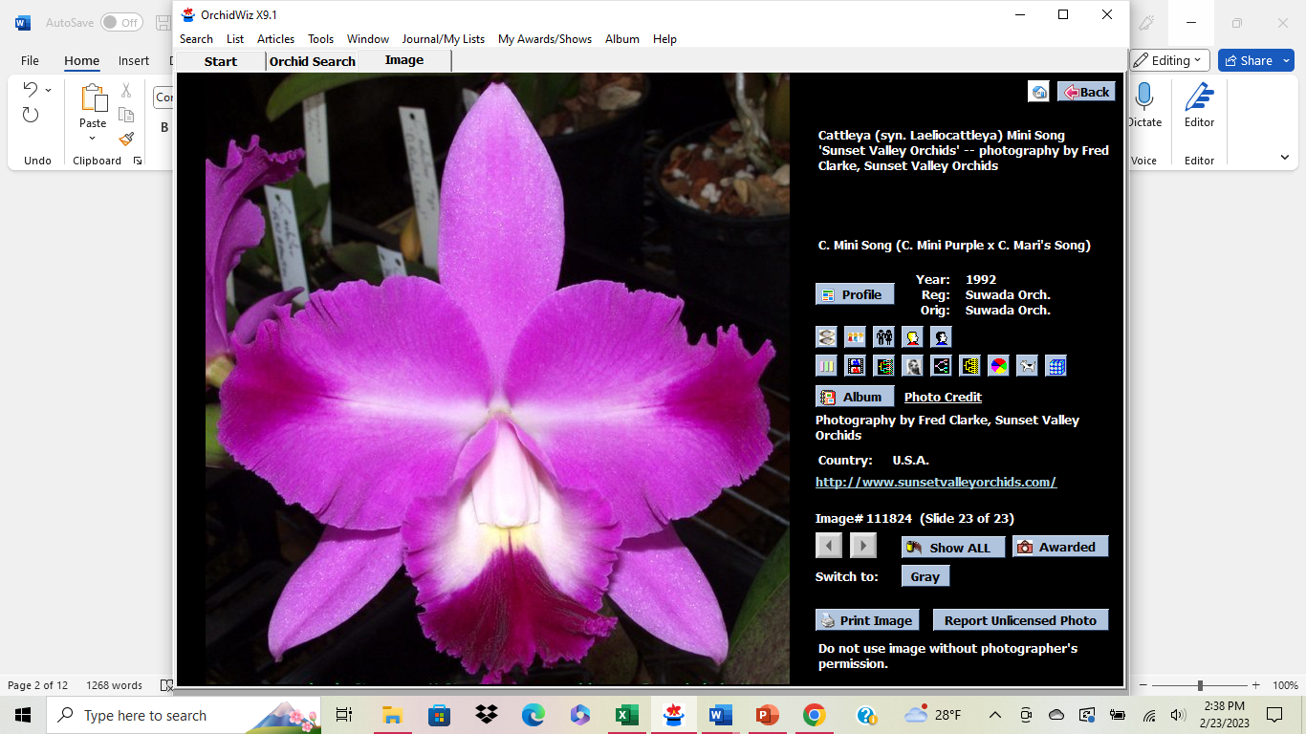

Lc. Dorothy Warne Lc. Mini Song ‘Petite’ Lc. Featherrae

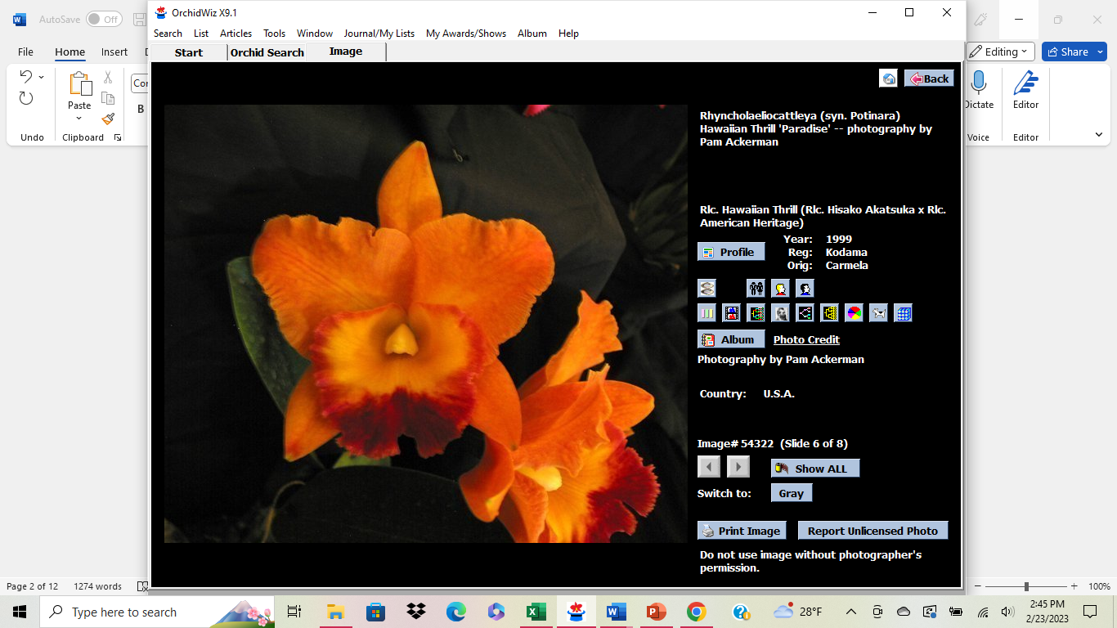 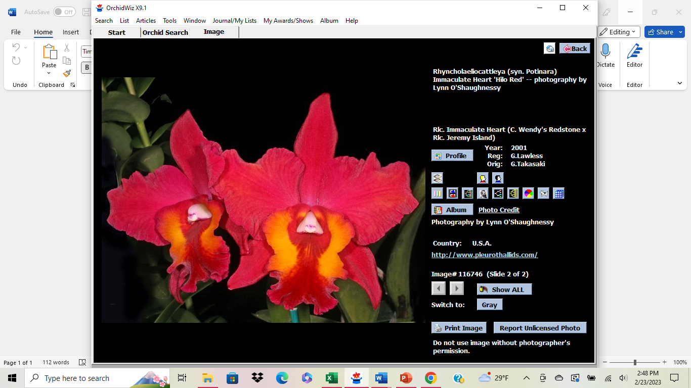 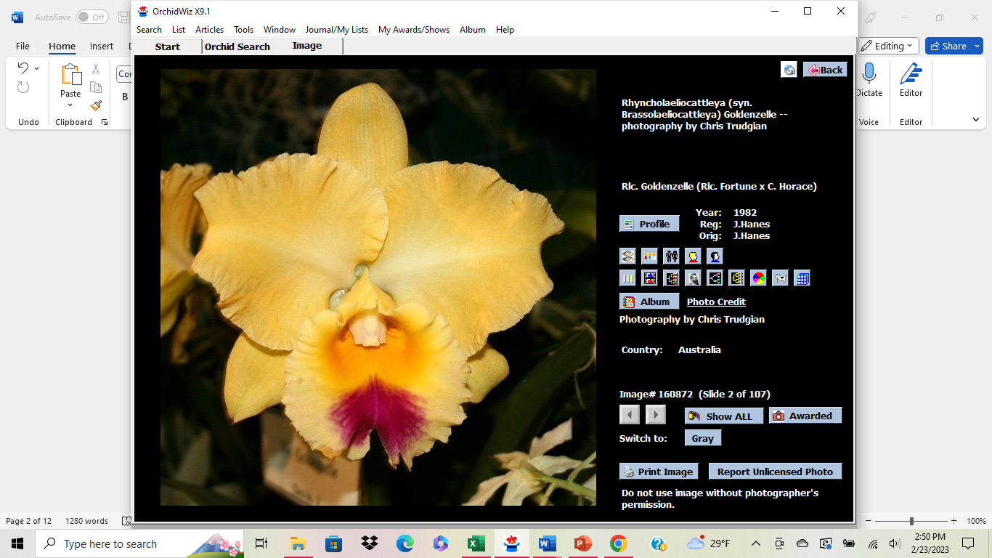

Pot. Hawaiian Thrill Pot. Immaculate Heart Blc. Goldenzelle

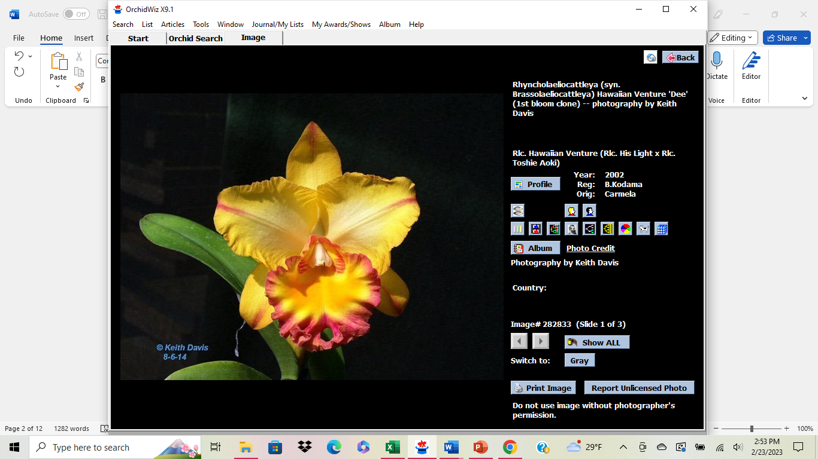 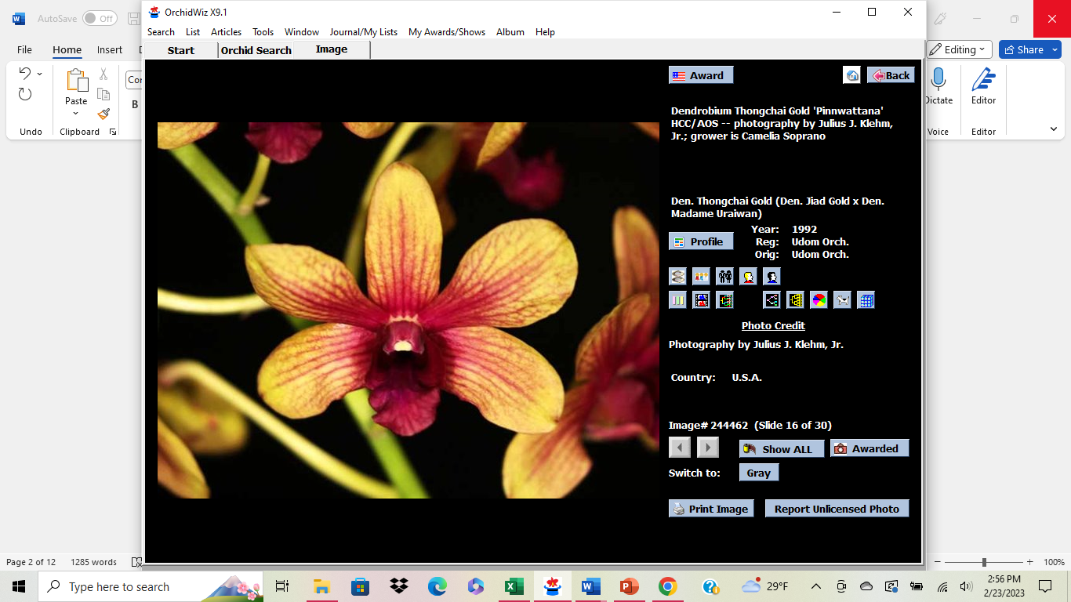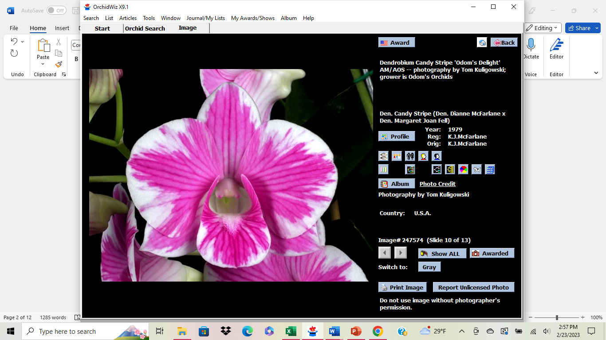

Blc. Hawaiian Venture (Den. Thong Gold x Den Candy Stripe)

These are the small plants available for mounting in April $10 for plant & mount

Cash or check please

**Presidents Message**

**It’s Still Orchid Show season!! NFOS put in a display in Rochester on Thursday 3/30/23, see details on next page. Our own Peter Martin won two AOS awards at GROS he will have them for viewing on April 4th at the meeting. Next show is WSOS April 21-23 volunteers needed for set up, fun show. In botanical gardens news we will assist the gardens with featuring orchids all through the conservatory in February 2024, it will end with our March show. They are committing to a substantial financial investment in buying orchids for us to display, we are excited about the possibilities. We continue to receive donations of plants and money from orchid societies, orchid judges and vendors from around the US, Hawaii, Thailand, and Taiwan. I’m optimistic that we will come**

**out of this far ahead of where we were before the storm damage.**

**Volunteers needed for**

**Orchid Repotting Service**

Thursday April 13th 5-8 pm

NFOS will be Repotting Orchids for the Buffalo community at the admin building.

We will be selling mix, orchiata, fertilizer, and pots. The public will purchase the supplies they need from us and our members will repot for them and give consultations.

I need help at the supply table & at repot stations. This is a new procedure which may prove to be more fruitful for us as the gardens provides their own advertising.

Win Win

GROS Orchid Show March 31st-April 2nd

Eisenhart Auditorium

657 East Ave.

Rochester, NY 14607

[**https://www.geneseeorchid.org/annual-orchid-show**](https://www.geneseeorchid.org/annual-orchid-show)**.**

**NFOS display at GROS 2023**

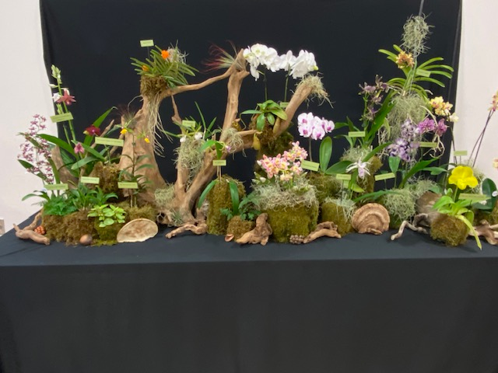

**Pics from NFOS Orchid Show**

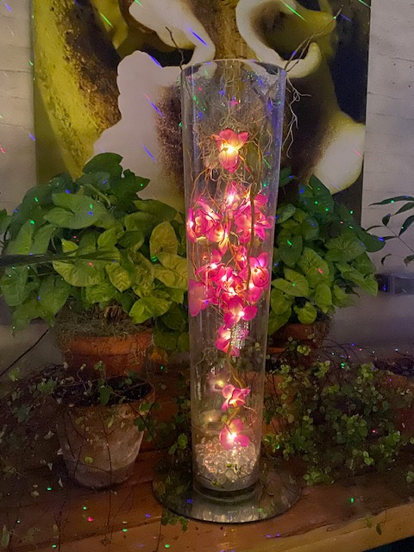 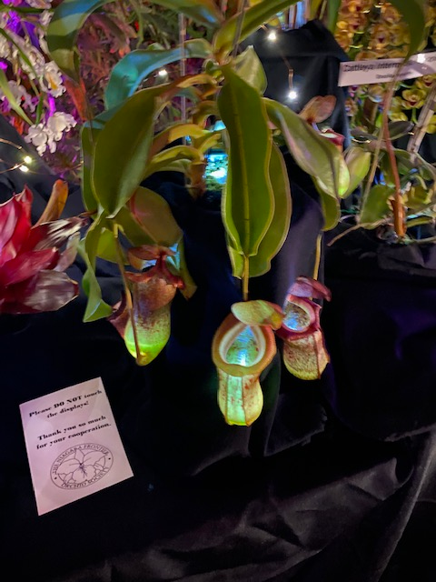

AOS Gala centerpieces redo Bergen’s illuminated Nepenthes

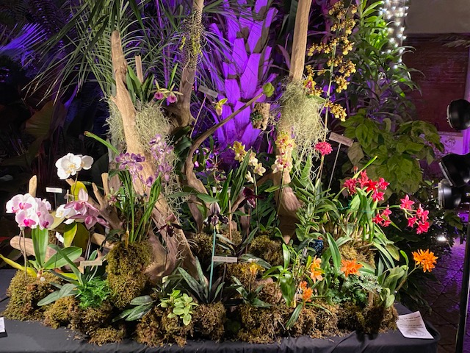

**NFOS Club display by Tom Price**

**NFOS Board Meeting Minutes 03/01/2023**

**The Board meeting was called to order on ZOOM at 8:03 PM. Present were Donna Lipowicz, Sue Charles, Peter Martin, Laurie Joyce, Barbara Domagala, Cyndi Robinson, Bob Hartman, and Jim Gibbons.**

**Donna noted that the set-up for the NFOS March show will begin on Friday March 3 at 10: 00AM. The BECBG will be closed that day. It will be a long weekend as the Gardens will be open from 6:30PM to 9:30PM both Friday and Saturday, with our members and vendors present from 10:00AM to 9:30PM both days, and from 10:00 AM to 4:00PM on Sunday. There will be pizza and wings available on Friday at 3:30PM for the set-up crew.**

**The gardens has cleared out many of the plants from the middle walkway in House # 9, so some of our members’ smaller orchid exhibits can be displayed there.**

**Donna reports that the Gardens received $7000 dollars towards the replacement of the orchid collection, and the NFOS is using $3000 dollars of that to order Cattleyas, Paphs, etc. from Chadwick and Sons in Virginia. Arthur Chadwick Jr. was a recent speaker at a NFOS membership meeting.**

**The Gardens has received a $250 dollars donation from the Kentucky Orchid Society towards the orchid collection.**

**The Genesee Orchid Society Show and Sale will be in Rochester from Thursday March 30 for set up from 10:00AM. AOS judging will be on Friday April 1, with the show open to the public from 1:00PM that day, and from 10:00AM on Saturday and Sunday. Plant registration: if you are bringing or sending plants for the NFOS exhibit, note that the GROS uses a different format than the one we use. Go on the GROS website to get the proper classifications, etc. for your plants.**

**The April NFOS membership meeting will feature “How to mount your orchids”. For $10 you will receive a plant, a cork mount, fishing line, etc., as well as hands on instructions.**

**The meeting was adjourned at 8:40PM>**

**Submitted by J. Gibbons**

2023 Orchid Shows

Jan 13-15 Tamiami Miami

Feb 4-5 GCOS Cleveland

March 3-5 NFOS Buffalo NY

Mar 31-Ap 2 GROS Rochester NY

April 21-23 WSOS Strongsville OH

April 21-23 STOS Binghamton NY

May 19-21 Redlands Homestead FL

August 25-27 OVOF Dayton OH **

Nov 12-13 NFOS Buffalo NY

**Shows we travel to and do a club display sign up at the meeting.**

**\*\*Bench show**

NFOS Board Members

President: Donna Lipowicz

Vice President: Sue Charles

Treasurer: Laurie Joyce

Corresponding Sec: Cynthia Robinson

Recording Sec: Jim Gibbons

Sunshine Chair: Barb Domagala

Hospitality Dir: Betsy Kusmierski

Webmaster: Dawn Conwell (2023)

Newsletter: (2023)

At large members; Jim G, Sue L, Peter M, Russ M, Fred P, Tom P, Karen M, Betsy K, Bob H, Dawn C,

Cyndi R, Barb D, Laurie J.

**NFOS 2023 Calendar**

**Jan 3rd How we grow orchids in Buffalo**

**Feb 7th  Tour of Huntington’s Orchid Collection**

**Mar 3-5 NFOS Spring Show + night hrs**

**Mar 7th No Monthly Meeting**

**April 4th Mounting orchids $10**

**April 13th Repotting event BG 5-8pm admin bldg.**

**May 9th Ron McHattan speaker**

**May 25th Repotting event at BG 5-8pm**

**June 6th Plant Swap**

**July**  **No monthly mtg**

**Aug No monthly mtg Picnic Sunday 8/13/23**

**Sept 5th Webinar**

**Sept Repotting Event**

**Oct 3rd Fred Clarke speaker**

**Nov 7th Show Prep**

**Nov 10-12 NFOS Fall Show Admin bldg.**

**Dec 5th Holiday Party**