NFOS Newsletter April 2024

Tuesday April 9th 2024, 6 PM

We will be potting up seedling Phalaenopsis that have been in community pots since Peter deflasked them in 2023.

Presidents Message

Happy Dyngus Day

Our March show was a success attendance numbers were 2548 for the weekend. The gardens is very pleased with the reviews of their 6 week orchid exhibit & our show weekend. NFOS has helped the gardens with extra revenue to continue improving the gardens experience.

The Darwin Martin house orchids were carefully repotted by Dawn & Sue & were returned to the Martin house for display. Thank you ladies.

Orchid season is in full swing now with shows each weekend. Sonnenburg gardens is having a show this coming weekend & we were invited to display. GROS is having their show April 28-30, NFOS will be setting up a club display so please send us your blooming orchids by Wednesday April 26. Orchids should be staked and ready for transportation please, with name tags.

Laurie tells me that several members have not renewed their membership yet for 2024, this is the last call for dues. I have enclosed the form if members still need to pay and can’t make the April meeting.

Donna Lipowiczl

NFOS Membership Form

Name: ____________________________

____________________________

Address: __________________________

__________________________

__________________________

Phone: ____________________________

Email_____________________________

_____________________________

Individual $15 _____

Family $20 ________

Make checks payable to NFOS

Mail to Laurie Joyce

33 Gates Circle 2D

Buffalo, NY 14209

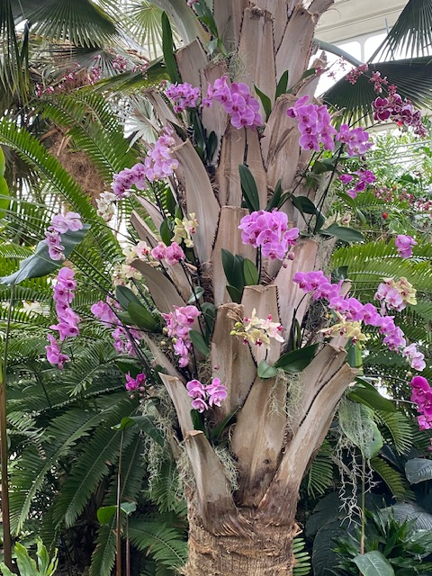 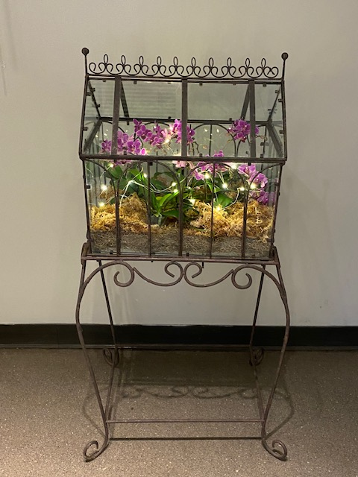

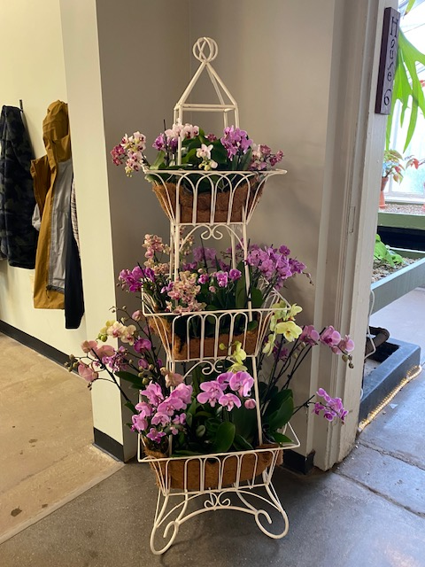 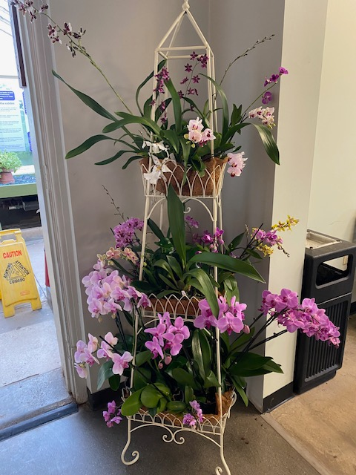

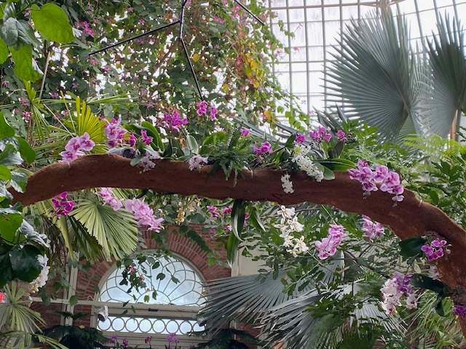

A few pictures of the orchid exhibit at the gardens

2024 Orchid Shows

Jan 18-Mar 3 Orchid Exhibit Buffalo

Feb 4-5 GCOS Cleveland

March 1-3 NFOS Buffalo NY

April 25-28 GROS Rochester NY

April 26-28 WSOS Strongsville OH

April 20-21 STOS Binghamton NY

May 17-19 Redlands Homestead FL

August 23-25 OVOF Dayton OH **

Oct 26-27 COOS Columbus OH

Nov 8-10 NFOS Buffalo NY

**Shows we travel to and do a club display sign up at the meeting.**

**Shows in black we do not display at.**

**\*\*Bench show**

NFOS Board Members

President: Donna Lipowicz

Vice President: Sue Charles

Treasurer: Laurie Joyce

Corresponding Sec: Cynthia Robinson

Recording Sec: Jim Gibbons

Sunshine Chair: Barb Domagala

Hospitality Dir: Betsy Kusmierski

Webmaster: Dawn Conwell

Newsletter: Donna

At large members; Jim G, Peter M, Russ M, Fred P, Karen M, Betsy K, Bob H, Dawn C,

Cyndi R, Barb D, Laurie J, Sue C,

**NFOS 2024 Calendar**

**Jan 9thFind out what’s happening at the Gardens**

**Feb 6th Find out what’s happening at the gardens**

**Mar 1-3 NFOS Spring Show + night hrs in greenhouses**

**Mar 5th No Monthly Meeting**

**April 9thPotting up Phal seedlings**

**May 7th Gardens update & repotting orchids**

**June 4th ??**

**July**  **No monthly mtg**

**Aug Picnic**

**Sept 3rd??**

**Oct 8th Eric Sauer speaker**

**Nov 5th Show Prep**

**Nov 8-10 NFOS Fall Show in Greenhouses**

**Dec 3rd Holiday Party Ilio DiPaolo’s**