NFOS Newsletter December 2022
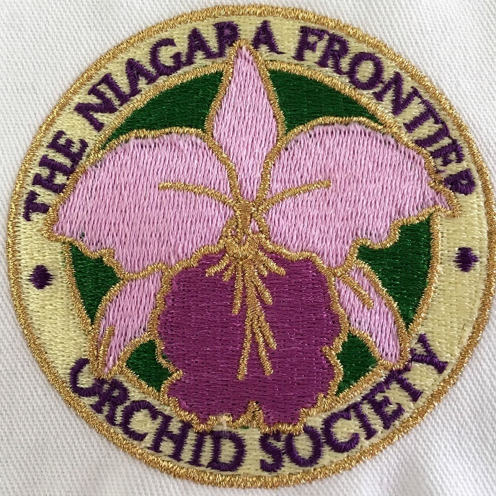

NFOS Holiday Party Dec 6th 6 pm
Chef’s Restaurant 291 Seneca St.
No gift exchange this year
Happy Holidays
Happy Hanukkah Dec 18-Dec 26
Merry Christmas Dec 25
Happy Kwanzaa Dec 26-Jan 1
Presidents Message
Well another year over another great orchid show by NFOS. Congratulations to Peter Martin for winning the show trophy for best exhibit! Attendance was 1200 visitors for our 2-day show. Typically, the March show is better attended than the November show. However, if 400 is the typical average weekend attendance at the gardens, our Nov show has tripled a typical weekend for the Botanical Gardens so job well done. Each of our vendors received an AOS award at the show, and it was the first one ever for Lily & Larry of Bergen Water Garden Nursery. Both Edgar (Windswept) & Jim (Oakwood) each got AOS awards. Welcome to Susan & Jerry Finger from CNYOS they also won an AOS award & they joined as new members of NFOS! Tuesday Dec 6th is our annual Holiday party we are expecting 24 members & NFOS will be in the French Connection Room which is immediately to the right after entering the doors.
NFOS Nov Mtg Minutes 11-08-2022
The Membership meeting was called to order by President Lipowicz at 6:15 PM.
The election for Board members was held, administered by Sue Lach. The current slate of officers was re-elected by a near unanimous vote (sorry, Sue Charles).
Preparations for the November AOS-Judged show, 11-13-2022 through 11-14-2022 were discussed in full. There are still ribbon clerks needed for Saturday morning’s judging. All clerks and judges are advised to be at the Botanical Gardens House 10 by 7:15 AM on Saturday. Staffing of the Club sales table and the raffle table are set. Classification paperwork and registration forms for plants submitted for judging are on the NFOS website. Paperwork should be submitted to Sue Charles by Thursday.
NFOS supplies stored below the Botanical Garden’s garage will have to be moved by Sunday 11-14-2022, as the garage is coming down. A location for our supplies has been designated in the Administration Building. Donna and Sue will get the move started Wednesday morning during our volunteer time at the Garden.
The club Show Table was presented by Miwako Leising and Steve Schop.
The guest speaker for the evening was Alan Koch, proprietor of Gold Country Orchids, in north central California. His topic was Species Habitat and Hybrid Culture. His main points were to know where and how our orchids grow in nature. Trying to fool Mother Nature never works. In addition he emphasized that in watering orchids and using fertilizers, the plant should be allowed to sit and drain for 25 minutes after fertilizer is applied, as that is the maximum length of time plant roots absorb the fertilizer. Then pure water, rain water, R/O water, or the like should be poured through the plant to get rid of chemical salts.
The meeting was adjourned at 9:15 PM.
Submitted by J. Gibbons

NFOS Board Mtg 10/26/22
The NFOS Board meeting was called to order on Zoom by President Lipowicz at 8:05 PM. Present in spirit were Donna Lipowicz, Cyndi Robinson, Peter Martin, Sue Charles, Russ Miller, Barbara Domagala, Laurie Joyce, and James Gibbons.
Donna reports that the Orchid collection at the Gardens is doing well, with many plants in spike, especially the Cattleya’s. The plants in the cold house, nobiles, dendrobiums, and cymbidiums will have to be moved due to wet conditions. The NFOS supplies at the Gardens will have to be relocated, due to the garage being torn down, possibly during our November show. Arrangements have been made to move everything to the Edmund building.
A meeting with the BECBG CEO has been postponed until after the November show.
Alan Koch of Gold Country Orchids will be the guest speaker at our November membership meeting on 11/08/2022. He will have orchids for sale.
Our November AOS judged orchid show set-up will be Friday 11/11/2022, beginning at Noon. Four orchid societies will be participating, the Central New York Orchid Society, the Genessee Region Orchid Society, the South Shore Orchid Society (from Ohio), and the NFOS.
Plant registration information, including updated forms, details, etc. are now on the NFOS website. The AOS judges want the plants to be displayed on long tables. Sue Charles has new table covers in NFOS colors.
Lunch will be supplied for the judges on Saturday, but side dishes from the members are needed for Friday and Saturday. Signup sheets will be available at the meeting on 11/08/2022.
The meeting was adjourned at 8:50 PM.
Minutes submitted by J. Gibbons

2022 Orchid Shows
March 5-6 NFOS Buffalo NY
March 25-27 GCOA Naples FL
April 1-3 GROS Rochester NY
April 6-10 AOS Coral Gables FL
April 23-24 WSOS Strongsville OH
April 23-24 STOS Binghamton NY
May 13-15 Tamiami Miami FL
August 26-28 OVOF Dayton OH **
Sept 30-2 CNYOS Baldwinsville NY
Oct 7-9 Redlands Homestead FL
Nov 4-5 Krull-Smith Apopka FL
Nov 12-13 NFOS Buffalo NY
Shows we travel to and do a club display sign up at the meeting. **Bench show

NFOS Board Members

President: Donna Lipowicz
Vice President: Sue Charles
Treasurer: Laurie Joyce
Corresponding Sec: Cynthia Robinson
Recording Sec: Jim Gibbons
Sunshine Chair: Barb Domagala
Hospitality Dir: Betsy Kusmierski
Webmaster: Dawn Conwell (2023)
Newsletter: Fee Bolden (2023)

At large members; Jim G, Sue L, Peter M, Russ M, Fred P, Tom P, Karen M, Betsy K, Bob H.

NFOS 2022 Calendar
Jan 4th Pick up Orchiata Admin
Feb 8th Setting up an orchid display Admin
Mar 1st Show prep in Greenhouse 10
Mar 4-6 NFOS Orchid Show
Apr 5th Paph henryanum Carlos Villarroel Admin
May 10th Arthur Chadwick speaker GH #10
June 7th Plant division & Plant Swap Admin
July 31st Russ Miller’s Hot Dog Roast 12 noon
Aug 21 NFOS Picnic Elma Meadows 2-6pm Bring a dish
Aug 26-28 OVOF/MAOC Kettering Ohio
Sept 13th Leon Glicenstein speaker Admin
Oct 4th Plant Sale/Show prep Admin
Nov 8th Alan Koch speaker Admin
Nov 11-13 NFOS Orchid Show
Dec 6th Holiday Party! Chef’s Restaurant

NFOS 2023 Calendar
Jan 3rd Planning Mtg.
Feb 7th Webinar
Mar 3-5 NFOS Spring Show + night hrs
Mar 7th Possibly skip as it is right after our show??
April 4th Mounting orchids
May 9th Ron McHattan speaker
June 6th Plant Swap
July Picnic ??? No monthly mtg
Aug No monthly mtg
Sept 5th Webinar
Oct 3rd Fred Clarke
Nov 7th Show Prep
Nov 10-12 NFOS Fall Show ????
Dec 5th Holiday Party

