NFOS Newsletter June 2021
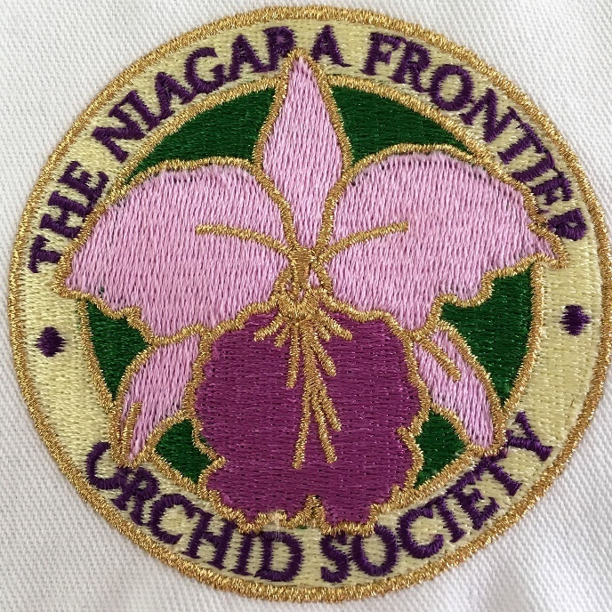
June In person mtg
Sunday June 27th 1:00 pm
Stiglmeier Park
Cheektowaga NY 14227
Member swap bring & take something
After entering park turn to your left and follow the winding road past tennis, football, and continue past stop sign and continue straight. We will be at a shelter past the big parking lot look for signs.
Presidents Message
I have been volunteering at the gardens for 5 weeks now. I’m watering in house 2 & 3 on Mondays from 8-10 am. This is not something I’ve done in the past but no one signed up to water the orchids in 2 & 3 so I decided to do it and it turned into me watering everything including the orchids. We have now been invited to come back to the orchid collection. 2 trained volunteers on Wednesday 8-10 am and 2 volunteers on Friday 8-10 am. I have enough trained volunteers to manage at this time, and a few others trained I can pull from.
Thank you to the volunteers who have committed to helping again.
I am not sure if we will ever go back to 12 people volunteering on a Wednesday, so I expect things to be different.
In other good news things are coming together for a November orchid show. I have Oakwood Orchids & Windswept in Time confirmed, show dates are November 12-14,2021. It sounds like we will have a very special guest to our show, Robert F. Fuchs President of AOS. According to Toronto Judging Ctr,
Bob is trying to travel around the US to AOS societies having shows this year. This is exciting news for NFOS & the gardens.

Donna Lipowicz

Mark your Calenders

Ohio Valley Orchid Fest Hosted by GCOS & MVOS

AUGUST 27-29, 2021 Registration is now open!!

ohiovalleyorchidfest.org

ohiovalleyorchidfest.com
BEEN LOCKED IN FOR MONTHS? COME TO DAYTON, OHIO FOR ORCHIDS AND MORE !!

AOS AND RIBBON JUDGING

GUEST SPEAKER BOB FUCHS FROM RF. ORCHIDS AND PRESIDENT OF THE AOS.

EMANUEL LUTHERAN CHURCH
4865 WILMINGTON PIKE
KETTERING OHIO!!!
Beautiful Orchids
Great Friends
Food Trucks
Auctions
Demos
Orchid Supplies
Orchid Talks
Vendors Orchid Outlet, Oakwood Orchids, New Vision Orchids, Windswept in Time Orchids, Natts Orchids, Orchid Inn, Little Frog, Robert’s Orchid Supplies, Ten Shin Orchids, Windy Hill, R. F. Orchids, Botanical, Tsuchibuta Pottery
NFOS AOS awarded Display

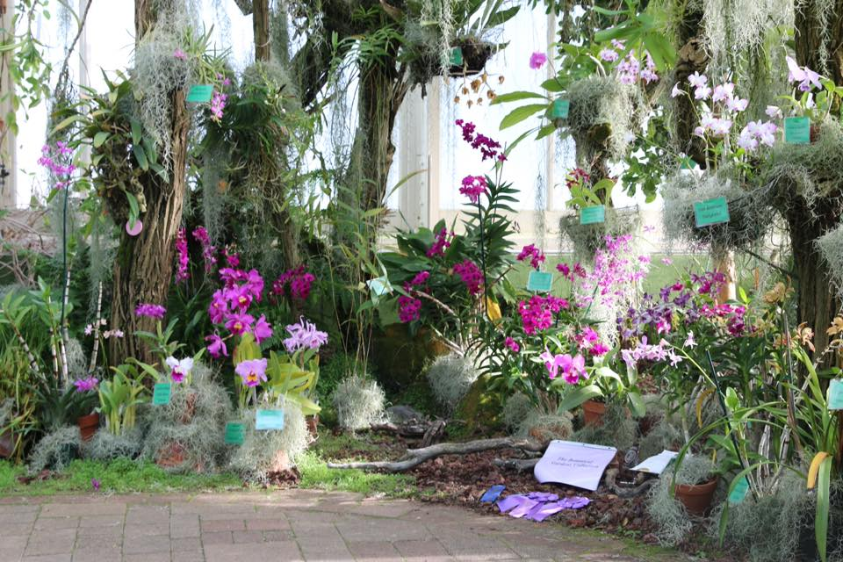

For Sale

- Osmunda
- Fir Bark
- Tree Fern
- Orchiata
- MSU
- Coconut fiber
- Moss
Interested please contact Donna by Friday before a mtg.
NFOS Library Book List

A History of the Orchid, Reinikka
ABC of Orchid Growing, Watkins
American Orchid Culture, White
Beginners Guide to Growing Phalaenopsis Orchids, Gordon (soft cover)
Botanica’s Orchids, (soft cover)
Bulbophyllums The Incomplete Guide, Thoms
Compendium of Orchid Genera, Alrich & Higgins
Culture of the Phalaenopsis Orchid, Gordon (spiral soft cover)
Fragrant Orchids, Frowine
Genus Phalaenopsis Orchid Digest Orchids of the World, Sweet
Growing & Displaying Orchids step by step Guide, Rittershausen, Oakly, Sutherland
Growing Orchids in Australia & New Zealand, Morrison (soft cover)
Growing your own Orchids, Rittershausen
Growing Windowsill Orchids, Seaton (soft cover)
Intro to Cultivated Angraecoid Orchids of Madagascar, Hillerman & Holst #2
Lycaste Orchids Cultivation & Hybridisation, Alcorn
Masdevallia Gems of the Orchid World, Gerritsen & Parsons
Miniature Orchids, Northen
Moth Orchids Complete Guide to Phalaenopsis, Frownie
Orchid Species Culture, Baker & Baker (soft cover)
Orchids, James (soft cover)
Orchids & Serendipity, Freed
Orchids for Dummies, Frowine (soft cover)
Orchids Flowers of Romance & Mystery, Kramer (soft cover)
Orchids of Brasil, Baptista, Harding, Neto
Orchids of Papua New Guinea, Millar
Orchids of South West Australia, Hoffman & Brown (soft cover)
Orchids as Houseplants, Rittershausen
Orchids Care & Cultivation, Terquem & Parisot (soft cover)
Orchids for Everyone, Williams
Orchid Growing for Wimps, Zachos (soft cover)
Orchids in Color, Rittenshausen (soft cover)
Orchids Simple steps to Success, Johnson (soft cover)
Orchids Illus Identifier & Guide to Cultivation, Tibbs & Bilton
Orchids Prac Guide to worlds fascinating plants, Ritterhausen
Orchids Simplified Indoor Gardening Guide, Jaworski (soft cover)
Orquideas de la costa del Ecuador, (soft cover)
Ortho’s Complete Guide to Orchids, (soft cover)
Ortho’s All About Growing Orchids, (soft cover)
Paphiopedilum Growers Manual, Birk
Rare Orchids Everyone Can grow, Kramer
Rare orchids, Davis & Kawaguchi
Sarcochilus Orchids of Australia, Upton
Simon & Schuster’s Guide to Orchids, Fanfani & Rossi (soft cover)
Success with Orchids, Rittershausen
Taylor’s Guide to Orchids, White (soft cover)
The World’s most beautiful Orchids, Allikas & Nash
The Illus Encyclopedia of Orchids, Pridgeon
The Orchid Expert, Hessayon (soft cover)
The Orchid Picture book, McDowell (soft cover)
The Prac Encyclopedia of Orchids, Ritterhausen
The Slipper Orchids, Cash
The Time Life Encyclopedia of Gardening Orchids, Skelsky
The Ward Lock Book of Orchid Growing, Black (soft cover)
The World of Catasetums, Holst
Understanding Orchids, Cullina #2
Vandas their Botany, History & Culture, Motes
Wild Orchids Across North America, Keenan

Pamplets
A Culture Manual for Aerangis Orchid Growers, Hillerman
A culture Manual for Angraecoid Orchid Growers, Hillerman
Growing Orchids, AOS Handbook
Lycaste Species the Essential Guide, Oakley
Orchids for the Home & Garden, Brooklyn Bot Garden
Orchid Growing Under Lights AOS Guide, Fitch
Orchid Pests & Diseases, AOS Guide
When Does it Flower? Orchid Species in the Greenhouse Since 1881, Hamilton
The library books are available to any member in good standing and must be returned in a reasonable time frame. You can text or call Donna at 479-7698

NFOS Board Members

President: Donna Lipowicz
Vice President: Sue Charles
Treasurer: Laurie Joyce
Corresponding Sec: Cynthia Robinson
Recording Sec: ??
Sunshine Chair: Barb Domagala

At large members; Al B, Jim G, Sue L, Miwako L, Peter M, Russ M, Fred P, Tom P, Rich S, Karen M. Tony A.

NFOS Board meetings have been held the Wednesday before our monthly meeting by zoom video, If you want to join let me know I’ll add you to the invite list All are welcome
NFOS Committees
Check for your name, if it’s not below come see Donna

Hospitality: Tom H, Pat B,
Programs: Peter M, Jim G, Tom P.
Show: Sue C, Jim G, Liz B.
Membership: Sue L, Ann H.
Vendors: Donna L, Peter M.
Road Shows: Barb D, Cyndi R.
Sales/Raffle: Laurie J, Karen M, Jamie C.
Elections: Sue L.
Advertising: Cyndi R.
Bot. Gardens: Russ M, Donna L.
News/Web: Donna L.
Beginners Grp: ??
NFOS 2021 Calendar
Jan 5, 2021 Volunteer Training 2021
Feb 8, 2021 GROS zoom Norman Fang
Feb 9, 2021 Show & Tell
Mar 8, 2021 GROS zoom Cymbidiums
Mar 9, 2021 Show & Tell AOS Webinar
Mar 20, 2021 MAOC zoom Orchid Tour + talks
April 6, 2021 Miltoniopsis vexillaria
May 23, 2021 In Person mtg Stiglmeier Park 1pm
June 27, 2021 Member SWAP Stiglmeier 1pm
July , 2021 In person mtg TBD
Aug , 2021 In person mtg TBD
August, 2021 Picnic ????
Sept 7, 2021 ?????
Oct 5, 2021 Doug Martin
Nov 9 & 12-14 Show prep & Orchid Show
Dec 7, 2021 Xmas Party Chef’s

