NFOS Newsletter June 2023

Next meeting is

Tuesday June 6th

Swap Night

6 pm in Admin Building

Divisions of orchids, can’t get it to bloom, books, lights, trays, orchid related items only please. Bring something take something.

**Volunteers needed for**

**Plant Society Avenue**

**June 24-25 10-3 pm**

**Garden Art Sale**

**Buffalo Botanical Gardens**

**We will be selling orchid supplies & encouraging membership**

**This is a fund raising event for NFOS**

**Vendors, food trucks, cool garden art items**

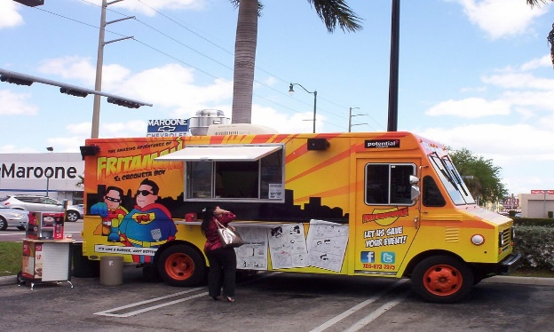

[This Photo](https://www.flickr.com/photos/southbeachcars/6811400876/) by Unknown Author is licensed under [CC BY](https://creativecommons.org/licenses/by/3.0/)

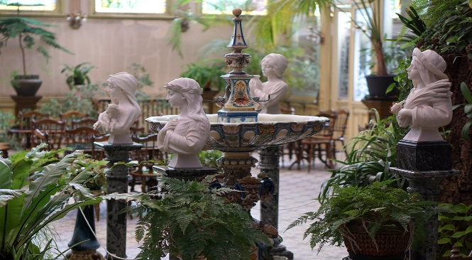

[This Photo](https://www.flickr.com/photos/sint-katelijne-waver/32163677747/in/photostream/) by Unknown Author is licensed under [CC BY-NC-ND](https://creativecommons.org/licenses/by-nc-nd/3.0/)

NFOS Board minutes May 31, 2023

President Lipowicz called the Board meeting to order, via ZOOM, at 8:00 PM. Present in spirit were Donna Lipowicz, Sue Charles, Peter Martin, Betsy Kusmierski, Dawn Conwell, Cyndi Robinson, Jim Gibbons, Barb Domagala, and Laurie Joyce.

There will be a signup sheet at the June Membership meeting for the annual NFOS Picnic, scheduled for Sunday, August 13, 2023. The Society will provide the meats, hot dogs, hamburgers, and possibly, Italian sausage. These will be cooked over charcoal by a professional chef. There will be a discussion at the June meeting over who will bring what side dishes. Coffee and water will be the beverages provided. It is expected that the attendance will be the same as last year, 35 to 40 people.

Donna reports that the most recent repotting exercise netted a profit of $429.00 to the Society. The next repotting event will be in September. There was a discussion as to making the event more convenient, as there were customers lined up at the Gardens at 4:00 PM, although it wasn’t scheduled to start until after 5:00 PM. Peter Martin, the repotting expert, said he was satisfied at how the event went, with he doing the final potting, and other members cleaning the pots, selling the medium, etc.

At the June Membership meeting, there will be a plant swap, bring a plant that you have had no success with, or have duplicates of, and get a plant. Everyone who brings a plant will get a raffle-style ticket and as your number is called, you can select a plant. Also anyone who ordered bags of Orchiata can pay and pick them up at that time. The price of our supplies has skyrocketted, with the Orchiata now $45.00 a bag, and the thin bricks of sphagnum moss, which we had been selling at its $8.00 cost, now $15.00. Shipping costs are a major part of the price increases.

Donna is looking for volunteers for a work party at the BECBG on Saturday June 17, between 9:00 AM and 11:00 AM, to straighten out our supplies in the basement of the Admin building. This includes bagging Orchiata, moving the full bags, MSU, etc. Bob Hartman will be in charge.

On June 10th various plant societies will have a garden sale. Betsy and Donna will be attending and participating.

The BECBG is holding a Garden Art Sale on the Garden’s Ring Road on Saturday and Sunday, June 24 and 25. The NFOS will have a table and sell potting supplies and recruit new members. There will be a signup sheet at the June Membership for volunteers to cover parts of the time.

The Erie County Fair has requested that the Society set up an exhibit, with the setup date August 8. The Fair runs from August 9th thru the 20th . The exhibit will be open the entire time, but no members are needed to man it.

The BECBG wants to have an Orchid Month in February 2024, ending with our March 2024 Show and Sale. To that end the gardens is planning a major orchid plant purchase, possibly as much as $15,000 to $20,000. The NFOS will be working with the Gardens to make that month a success, with diverse exhibits in every greenhouse, lobby and hallway, with the possible exception of the cactus greenhouse (too hot and dry).

It's not too late to think of the Christmas party. If we return to Chef’s we need a larger room than last year. Members are asked to come up with possible alternatives. Submitted by Jim Gibbons

NFOS Native Orchid Walk 5/19/23

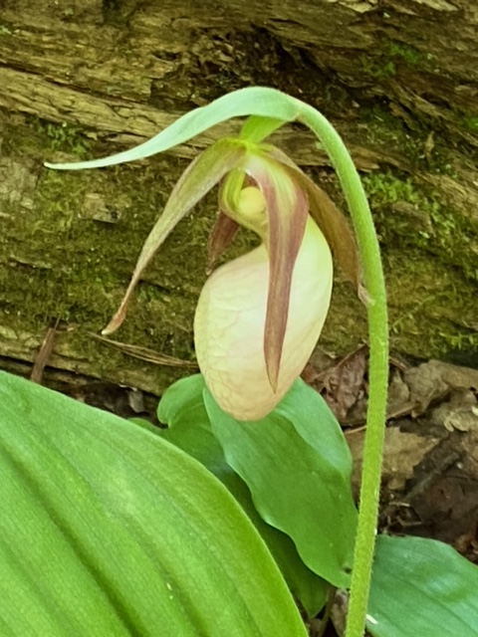 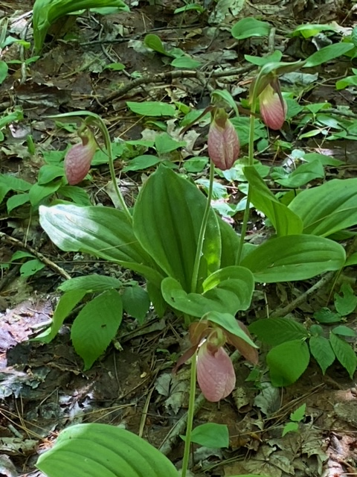

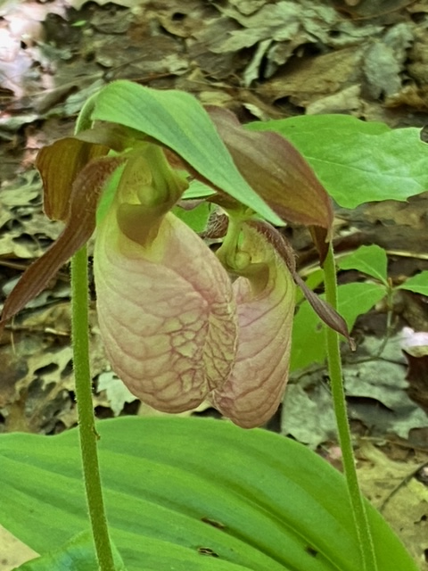 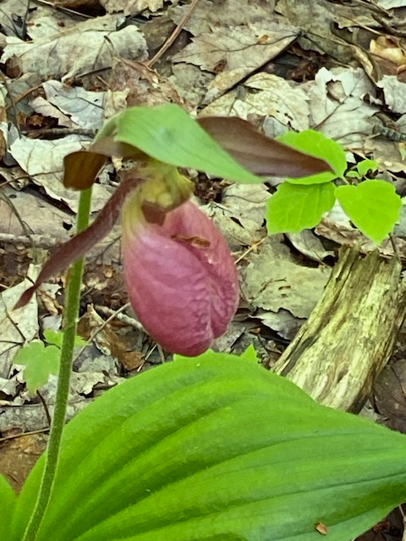

**Here is the list of guided walks in WNY**

**Native orchids are some of the plants you will see**

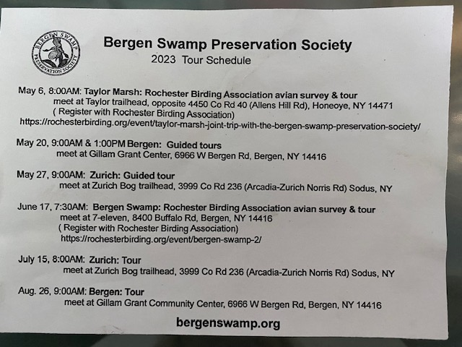

CNYOS:

Central NY is inviting us to their auction

NEXT MEETING: Sunday JUNE 4TH at 2pm

Please make note of the program! We will be having an AUCTION so bring anything plant related that you would like to donate to the club. Remember, this is our only fundraiser scheduled yearly.

I am hoping to have a large number of plants from Orchid Greenhouses in Ohio, California, Florida, and Hawaii.

Other area Societies will be notified and invited to attend. Any members who also hold memberships to other areas should be sure to contact their newsletter editor so we don't miss anyone.

Payments will be accepted by Cash or Check only.

If shipments come in early enough, I will send an email to members with the names of the plants available.

SAME DATE / SAME MEETING is our Annual Picnic! Please bring a dish to pass, and your own table service/beverage. There will be plenty of time to browse the plants for sale after a quick meal. Business will be at a bare minimum! Too much fun to be had!!

Niagara Frontier Orchid Society

Annual Picnic

Sunday August 13th 2PM

Elma Meadows Park Shelter #1

Orchid Society Will Provide Hot Dogs

Burgers, Coffee, Water & Soda

Please sign up at June meeting!

Electric Available Eating @ 4PM



[This Photo](https://freepngimg.com/png/77376-king-whopper-hamburger-gourmet-cheeseburger-bacon-specialty) by Unknown Author is licensed under [CC BY-NC](https://creativecommons.org/licenses/by-nc/3.0/)

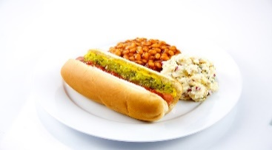

[This Photo](https://www.flickr.com/photos/preppybyday/5076302063/) by Unknown Author is licensed under [CC BY](https://creativecommons.org/licenses/by/3.0/)

Elma Meadows Located at 1711 Girdle Road 14059

Bring a Chair if Possible

2023 Orchid Shows

Jan 13-15 Tamiami Miami

Feb 4-5 GCOS Cleveland

March 3-5 NFOS Buffalo NY

Mar 31-Ap 2 GROS Rochester NY

April 21-23 WSOS Strongsville OH

April 21-23 STOS Binghamton NY

May 19-21 Redlands Homestead FL

August 25-27 OVOF Dayton OH **

Oct 28-29 COOS Columbus OH

Nov 12-13 NFOS Buffalo NY

**Shows we travel to and do a club display sign up at the meeting.**

**\*\*Bench show**

NFOS Board Members

President: Donna Lipowicz

Vice President: Sue Charles

Treasurer: Laurie Joyce

Corresponding Sec: Cynthia Robinson

Recording Sec: Jim Gibbons

Sunshine Chair: Barb Domagala

Hospitality Dir: Betsy Kusmierski

Webmaster: Dawn Conwell (2023)

Newsletter: (2023)

At large members; Jim G, Sue L, Peter M, Russ M, Fred P, Tom P, Karen M, Betsy K, Bob H, Dawn C,

Cyndi R, Barb D, Laurie J.

**NFOS 2023 Calendar**

**Jan 3rd How we grow orchids in Buffalo**

**Feb 7th  Tour of Huntington’s Orchid Collection**

**Mar 3-5 NFOS Spring Show + night hrs**

**Mar 7th No Monthly Meeting**

**April 4th Mounting orchids $10**

**April 13th Repotting event BG 5-8pm admin bldg.**

**May 9th Ron McHattan speaker**

**May 25th Repotting event at BG 5-8pm**

**June 6th Plant Swap**

**July**  **No monthly mtg**

**Aug No monthly mtg Picnic Sunday 8/13/23**

**Sept 5th How to register your plant for our Nov Show**

**Oct 3rd Fred Clarke speaker**

**Nov 7th Show Prep**

**Nov 10-12 NFOS Fall Show Admin bldg.**

**Dec 5th Holiday Party**