NFOS Newsletter March 2023

Next meeting is

Tuesday April 4th

6 pm in Admin Building

**How to Mount Orchids**

**Pick out one of the lovelies and mount it yourself!**

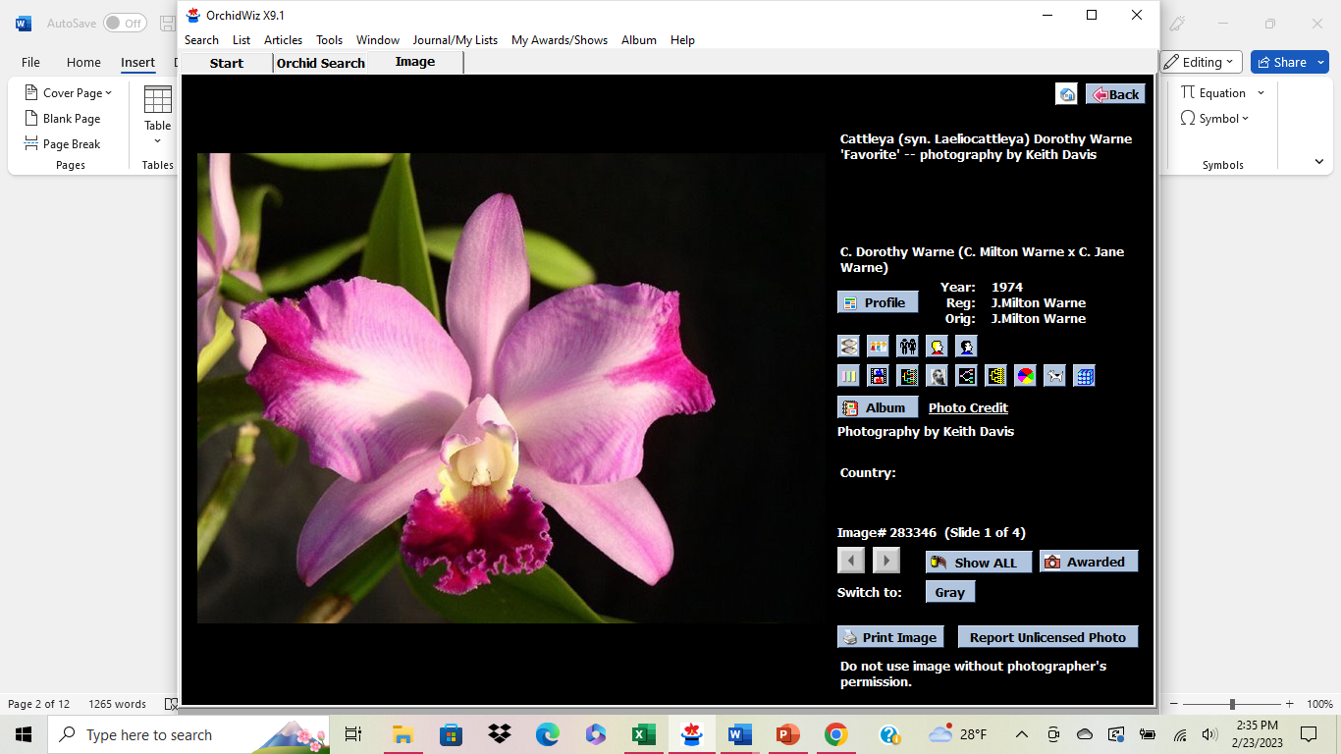 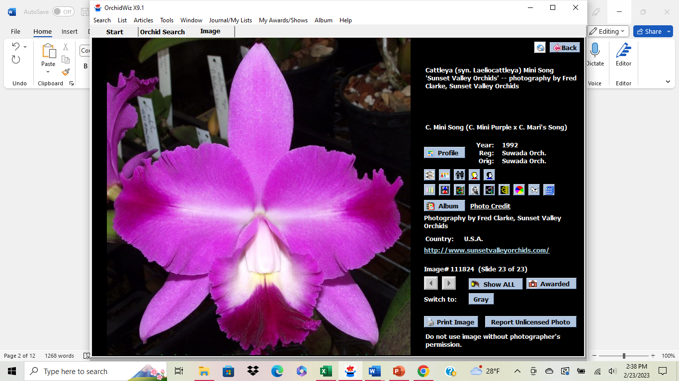

Lc. Dorothy Warne Lc. Mini Song ‘Petite’ Lc. Featherrae

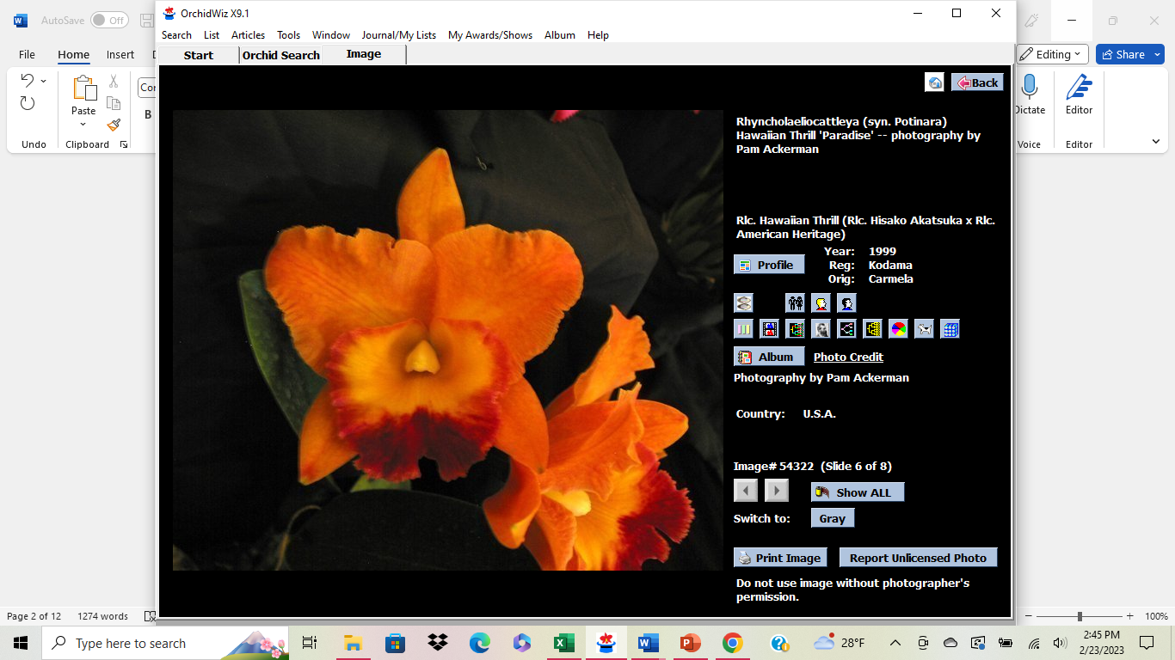 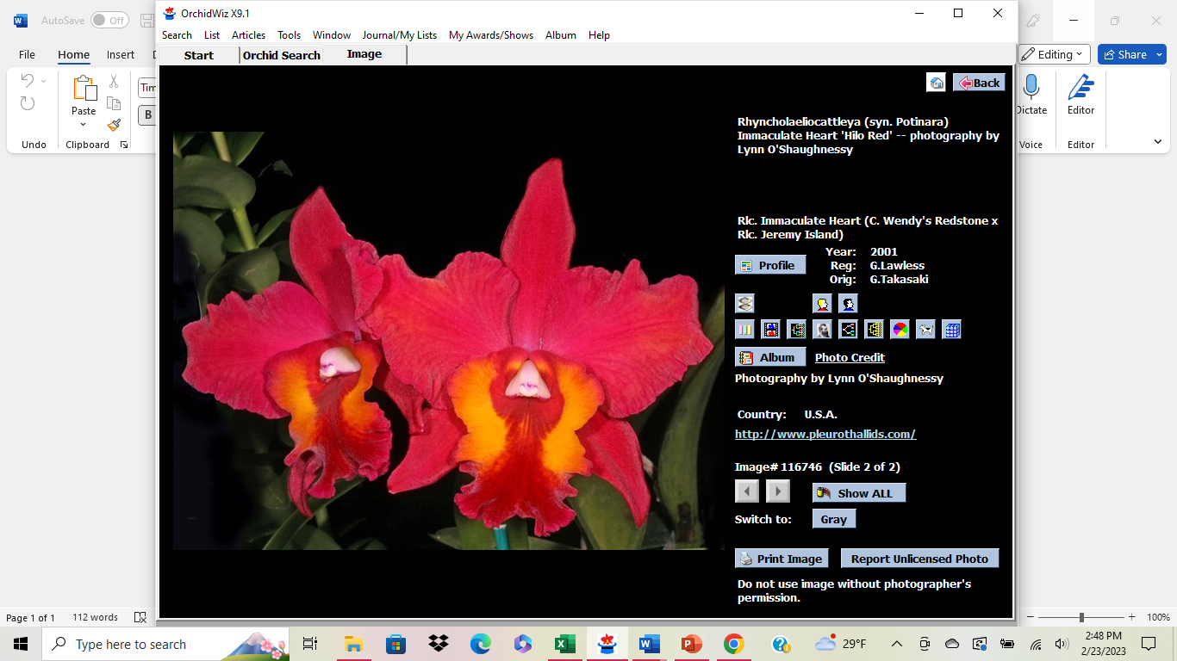 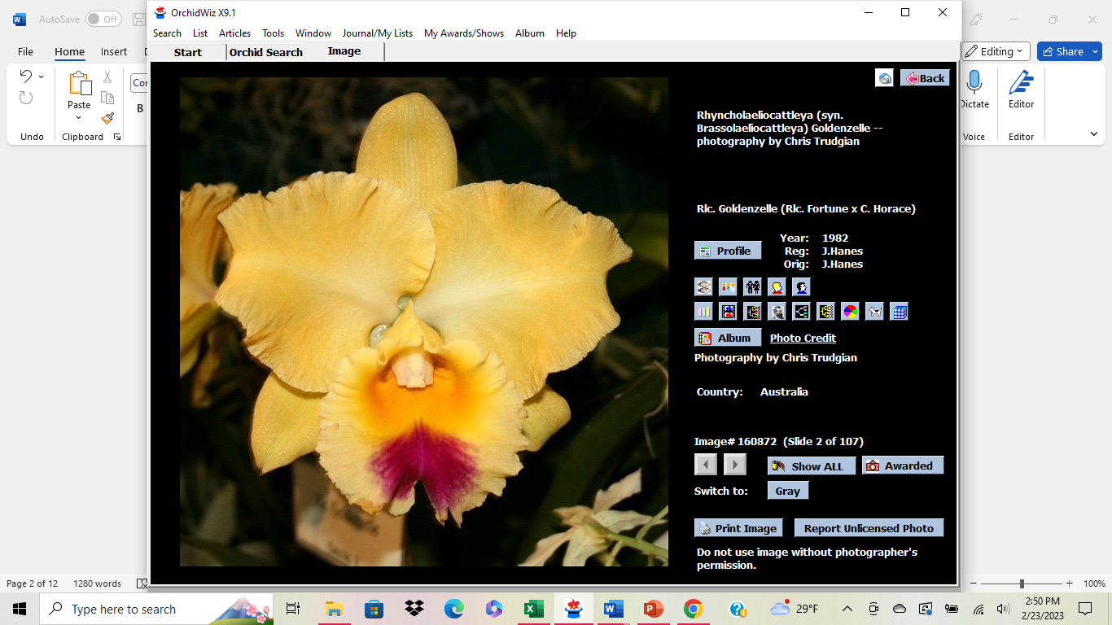

Pot. Hawaiian Thrill Pot. Immaculate Heart Blc. Goldenzelle

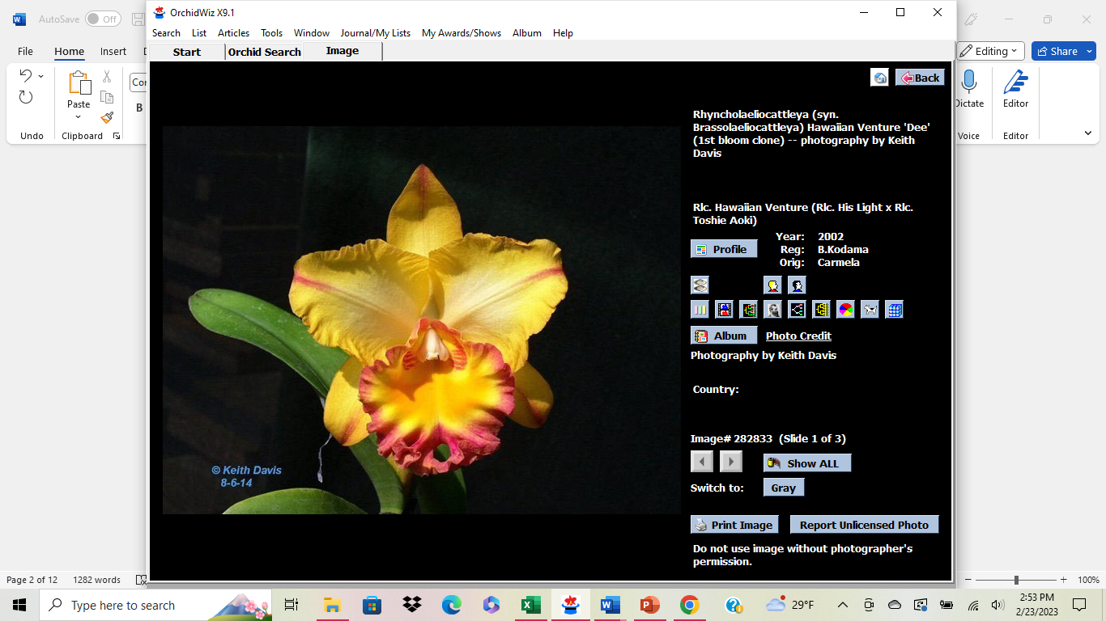 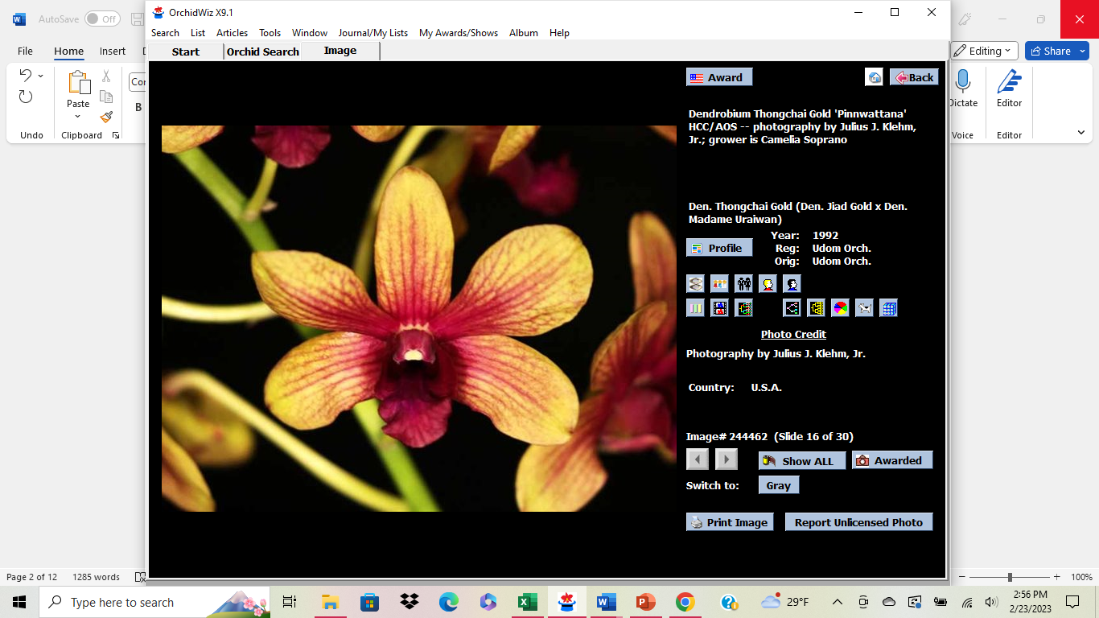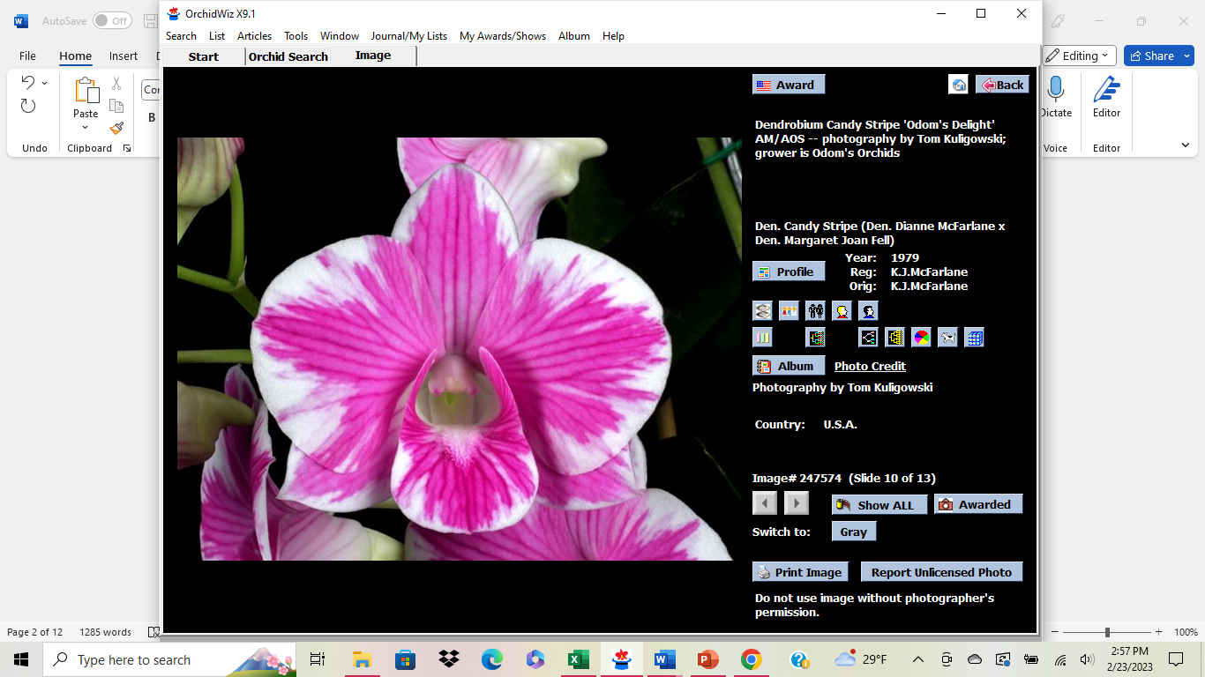

Blc. Hawaiian Venture (Den. Thong Gold x Den Candy Stripe)

These are the small plants available for mounting in April $10 for plant & mount

Cash or check please

**Presidents Message**

**It’s Orchid Show season!!**

**I hope you didn’t miss our after dark orchid show, we had almost 2400 come in during the weekend. We will hear the show report at the April meeting on the 4th.**

**I want to welcome our newest member’s**

**Karen K, Brianna Y, Anna S, Gayle H, & Linda I, as well as some returning members Dan & Barb P, Nadira P, & Tim S.**

**We made trips to Cleveland Botanical Gardens**

**And Phipps Botanical Gardens to view their Orchid Shows they purchase thousands of orchids and place them in pots and large arrangements which provide nice pops of color. Much different from what we do here at our shows, with a mix of smaller individual displays that are more elegant and intimate. All the vendors were pleased and wish to return in the fall for November show.**

GROS Orchid Show March 31st-April 2nd

Eisenhart Auditorium

657 East Ave.

Rochester, NY 14607

[**https://www.geneseeorchid.org/annual-orchid-show**](https://www.geneseeorchid.org/annual-orchid-show)**.**

**Blooming Plants needed for GROS Show**

**Drop off day at the gardens will be**

**Wednesday March 29th**

**8:30-10:30 am**

**Alternate drop offs can possibly be arranged reach out if needed- text 716-479-7698**

**Please visit GROS webpage noted above.**

**Their class schedule is different than ours so please have the proper name either species or hybrid with parentage with your plant. Please pack for transit with blooms protected.**

**Thank you for your attention to this.**

**Pics from NFOS Orchid Show**

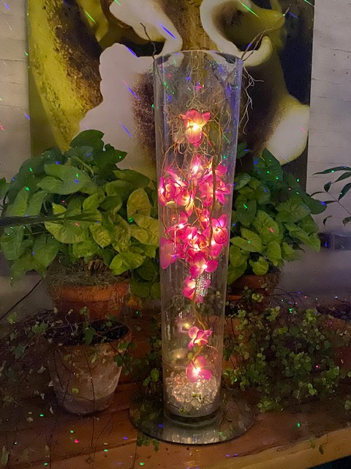 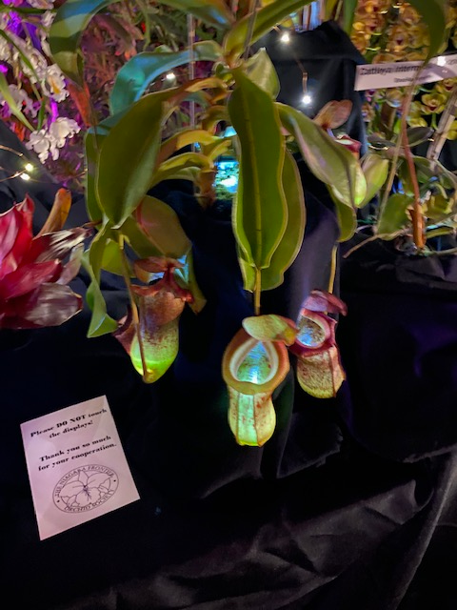

AOS Gala centerpieces redo Bergen’s illuminated Nepenthes

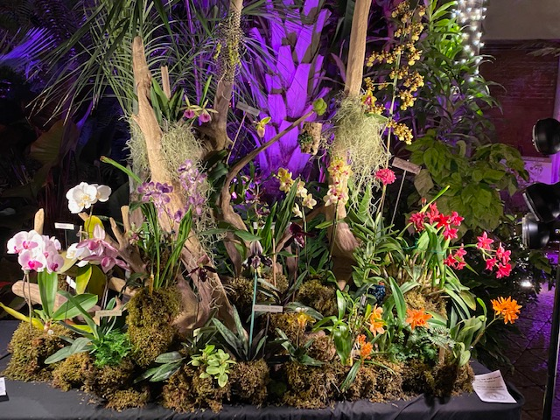

**NFOS Club display by Tom Price**

**NFOS Board Meeting Minutes 03/01/2023**

**The Board meeting was called to order on ZOOM at 8:03 PM. Present were Donna Lipowicz, Sue Charles, Peter Martin, Laurie Joyce, Barbara Domagala, Cyndi Robinson, Bob Hartman, and Jim Gibbons.**

**Donna noted that the set-up for the NFOS March show will begin on Friday March 3 at 10: 00AM. The BECBG will be closed that day. It will be a long weekend as the Gardens will be open from 6:30PM to 9:30PM both Friday and Saturday, with our members and vendors present from 10:00AM to 9:30PM both days, and from 10:00 AM to 4:00PM on Sunday. There will be pizza and wings available on Friday at 3:30PM for the set-up crew.**

**The gardens has cleared out many of the plants from the middle walkway in House # 9, so some of our members’ smaller orchid exhibits can be displayed there.**

**Donna reports that the Gardens received $7000 dollars towards the replacement of the orchid collection, and the NFOS is using $3000 dollars of that to order Cattleyas, Paphs, etc. from Chadwick and Sons in Virginia. Arthur Chadwick Jr. was a recent speaker at a NFOS membership meeting.**

**The Gardens has received a $250 dollars donation from the Kentucky Orchid Society towards the orchid collection.**

**The Genesee Orchid Society Show and Sale will be in Rochester from Thursday March 30 for set up from 10:00AM. AOS judging will be on Friday April 1, with the show open to the public from 1:00PM that day, and from 10:00AM on Saturday and Sunday. Plant registration: if you are bringing or sending plants for the NFOS exhibit, note that the GROS uses a different format than the one we use. Go on the GROS website to get the proper classifications, etc. for your plants.**

**The April NFOS membership meeting will feature “How to mount your orchids”. For $10 you will receive a plant, a cork mount, fishing line, etc., as well as hands on instructions.**

**The meeting was adjourned at 8:40PM>**

**Submitted by J. Gibbons**

**NFOS Minutes 02/07/2023**

**The membership meeting of the NFOS was called to order by President Lipowicz at 6:10 PM. There were 21 members present. The minutes of the January meeting and the last Board meeting were accepted on a motion by Liz Brady, seconded by Jim Gibbons.**

**Donna gave a report on the Cleveland Orchid Society Show. The NFOS display was awarded the First Place ribbon for a club exhibit, out of four societies competing. Our membership cleaned up on awards, with Betsy Kusmierski receiving four ribbons out of the five plants she exhibited, Ribbons were also awarded to plants exhibited by Donna, Sue Charles, Peter Martin, Barb Domagala, and Fred Phillips. The award winning plants were presented for our members’ viewing, in lieu of a show table.**

**Sue Charles had the chance to meet with the Cleveland Society’s IT person, and it is hoped that there will be no problems with plant registration at our November AOS judged show.**

**Donna is still cataloging the BECBG orchid collection, trying to price the replacement costs for the orchids lost in the 2022 Christmas Blizzard. She has the general figure of $10,000 so far, trying to match the size and variety, genus and species of the lost plants. She notes that the Gardens is negotiating with their insurance company, with no word on progress. She reports that in the near future the orchid greenhouse is going to be torn down, with the plants now on display moving to House # 9, the long hallway leading to house #10 (the greenhouse with the kitchen where we have set up for our shows in the past).**

**Donna discussed the food requirements for our March show. There will be pizza and wings for the setup crew on Friday, with the actual show starting at 6:30 PM. On Saturday the NFOS will provide the meats and rolls, with the members bringing in the side dishes.**

**Tentative plans for the NFOS picnic were discussed, with a general consensus that it should be held in early August at the same location as last year. Hopefully the yellow jackets will be gone.**

**A webinar on the orchid collection at the Huntington Gardens near Los Angeles was shown, putting our collection to shame.**

**The meeting was adjourned at 7:50 PM.**

**NFOS Board Meeting Minutes 01/25/2023**

**The meeting was called to order at 8:05 pm. by President Lipowicz via ZOOM. Present were Sue Charles, Laurie Joyce, Barbara Domagala, Russ Miller, Fee Bolden, Dawn Conwell, Bob Hartman, Cyndi Robinson, Peter Martin, Betsy Kusmierski, and James Gibbons.**

**Upcoming Orchid Shows were discussed. In March, the Society will be providing ham, and roast beef sandwiches, but salads, side dishes, and desserts are in short supply. A sign-up sheet to more equitably divide the food choices will be available at the February meeting. Sue Charles will be ordering plants for the March raffle table from Carmela Orchids in Hawaii, but she is holding off, waiting to see their February specials, and to avoid receiving plants in bloom too early for our show.**

**Multiple difficulties with our November AOS-Judged show were presented. As previously noted, the BECBG has booked a wedding for that same weekend, and requested that the NFOS reschedule our Show. It was explained to the Gardens director and senior staff that that the Toronto Judging Center can’t rearrange their schedule at short notice, and if the judges can’t appear, we will lose the dates for our November show for future years, and local Orchid societies won’t come to an unjudged show. Donna advised that there are many other societies that would snap up our reserved weekends in a flash.**

**Sue and Donna have been seeking alternative locations for the November show, without success. After much discussion, the BECBG has offered the Administration Building as the November venue. The vendors will set up around the outer walls of the main floor, with the exhibits, raffle table, etc., in the middle of the room, much as it was for the recent MAOC Show. The AOS judging will be held in the Admin basement. The Gardens staff will assist by moving everything back to the walls, and will supply and set up black cloth and PVC piping to separate the exhibits.**

**In addition there is a major problem with the plant registration software, which was unusable at the last November show, causing Sue Charles to look for a tall bridge to jump from. The Cleveland IT specialist was unavailable to assist last November, and one reason we will be attending the early February show in Cleveland is to get the software straight. If we can’t get the plants registered in November, we will have to cancel AOS judging and beg the Toronto Judging Center to show us some forebearance for future scheduled shows. The same, or similar problem, fazed the GROS at their last judged show.**

**Regarding the Cleveland Orchid Society Show the first weekend in February, set up and take down people are arranged. We still need flowering plants for the NFOS exhibit there, and Donna asks that plants be dropped off at the orchid room in the BECBG by February 1st. Every plant/pot should have the owners’ name attached.**

**In BECBG news, Donna, Sue and Tom Price met with the Garden’s director, who expressed dismay at the blizzard destruction of the orchid collection. Donna had catalogued the lost plants by type, variety, size and prospective replacement cost, which she estimated at $ 10,000, on her own, and the seven hours she spent on the internet to gather the information. She has supplied this information to the BECBG. The Gardens is negotiating with their insurance about plant replacement. The Garden has received a $100 donation already, designated for the orchid collection, and the NFOS has received $400 from the MAOC for the same purpose. In addition we have received offers of plant donation, to be received in the Spring, from many vendors, growers and fellow societies, with past AOS president Bob Fuchs promising a substantial plant donation from his own collection.**

**In addition, the orchid collection will be moving to benches in the far greenhouse attached to the Admin building, by Gardens staff, with sunlight and watering benefits. Shade cloth will be hung to protect the plants from errant golf balls from the South Park course (no joke). The Garden Administration is asking that the Society catalog the entire collection, and is also requesting that our plant repotting services to the public be moved and curtailed, to “Repotting Events”.**

**Submitted by James Gibbons**

2023 Orchid Shows

Jan 13-15 Tamiami Miami

Feb 4-5 GCOS Cleveland

March 3-5 NFOS Buffalo NY

Mar 31-Ap 2 GROS Rochester NY

April 21-23 WSOS Strongsville OH

April 21-23 STOS Binghamton NY

May 19-21 Redlands Homestead FL

August 25-27 OVOF Dayton OH **

Nov 12-13 NFOS Buffalo NY

**Shows we travel to and do a club display sign up at the meeting.**

**\*\*Bench show**

NFOS Board Members

President: Donna Lipowicz

Vice President: Sue Charles

Treasurer: Laurie Joyce

Corresponding Sec: Cynthia Robinson

Recording Sec: Jim Gibbons

Sunshine Chair: Barb Domagala

Hospitality Dir: Betsy Kusmierski

Webmaster: Dawn Conwell (2023)

Newsletter: (2023)

At large members; Jim G, Sue L, Peter M, Russ M, Fred P, Tom P, Karen M, Betsy K, Bob H, Dawn C,

Cyndi R, Barb D, Laurie J.

**NFOS 2023 Calendar**

**Jan 3rd How we grow orchids in Buffalo**

**Feb 7th  Tour of Huntington’s Orchid Collection**

**Mar 3-5 NFOS Spring Show + night hrs**

**Mar 7th No Monthly Meeting**

**April 4th Mounting orchids**

**May 9th Ron McHattan speaker**

**June 6th Plant Swap**

**July** **Picnic ??? No monthly mtg**

**Aug No monthly mtg**

**Sept 5th Webinar**

**Sept 16th Repotting Event 5-8pm**

**Oct 3rd Fred Clarke speaker**

**Nov 7th Show Prep**

**Nov 10-12 NFOS Fall Show Admin bldg.**

**Dec 5th Holiday Party**