NFOS Newsletter June 2023

Next meeting is

Tuesday June 6th

Swap Night

6 pm in Admin Building

Divisions of orchids, can’t get it to bloom, books, lights, trays, orchid related items only please. Bring something take something.

NFOS Board Meeting April 26, 2023

The meeting was called to order by President Lipowicz at 8:00 PM. Present by ZOOM were Donna Lipowicz, Cyndi Robinson, Peter Martin, Russ Miller, Jim Gibbons, Sue Charles, Barbara Domagala, Dawn Conwell, and Bob Hartman.

The guest speaker at the NFOS May membership meeting, May 9, 2023, will be Dr. Ron McHatton, the Chief Science and Education Officer of the American Orchid Society, the editor of Orchids magazine, and the host of the monthly Greenhouse Chat (Orchid Q and A) Webinars. There was a discussion on the possible subject of his presentation on May 9th, with the choices being : Paphs/cultural groups, and Pots and Media. The consensus of the Board was Paphs.

Donna reported that the Repotting Night brought in $89. The Gardens has scheduled a second Repotting Event for May 25th, from 5:00PM to 8:00PM. Again, all proceeds will come to the NFOS.

There will be a Work Party at the Gardens on Saturday May 6 from 9:00AM to 11:30AM. This will be to organize our new supplies and start to move stuff to the new greenhouse. Volunteers are needed.

Volunteers are also needed to man a NFOS table during the Plant Society Avenue at the Garden Art Sale, June 24 and 25. We can sell orchid supplies, but no plants. Volunteers are also needed to plan an exhibit for the Erie County Fair, August 9th thru the 20th, in the Agra Building.

At the West Shore Orchid Show outside Cleveland, Peter Martin received an AOS award for Paph. hirsutissimum with 3 flowers, and a plant previously donated to the Botanical Gardens by Ten Shin from Taiwan, Vanda miniata was named Best In Show.

The NFOS Picnic is scheduled for August 13, at Elma Meadows Park, from 12 Noon to 6:00PM. The Society is supplying the meat, and the members will supply side dishes and other items. There will be a sign-up sheet at our next membership meetings so there will be no duplications.

Donna will be ordering two flasks of Phalaenopsis seedlings, from Carter and Holmes orchids, at a cost of $100. She has also used a donation from the MAOC to purchase Paphs from Oakwood Orchids, who had attended our Spring Show with his wife and two Dobermans.

The Ohio Orchid Fest in Dayton, Ohio, will be held August 25 thru the 27th. The guest speaker will talk on Novelty Phalaenopsis. NFOS members have attended this show in the past and all members are encouraged to make the trip this year.

There are a number of field trips, to view native orchids, coming up. There is a guided tour at the Bergin Swamp, May 20th from 9:00AM to 1:00PM. A tour of the Zurich Bog in Sodus/Geneva NY on May 27th. There will be a chance to view native Ladyslippers in Eden at the end of May. Further information to follow.

Dawn Conwell, our IT expert, reports that she had a long and fruitful discussion with the IT person from the South Shore Orchid Society during their show and believes/hopes there will be no complications with orchid registrations at our Fall Judged show.

The meeting closed at 9:10PM.

Minutes submitted by J. Gibbons

**Volunteers needed for**

**Orchid Repotting Service**

Thursday May 25th 5-8 pm

NFOS will be Repotting Orchids for the Buffalo community at the admin building.

We will be selling mix, orchiata, fertilizer, and pots. The public will purchase the supplies they need from us and our members will repot for them and give consultations.

I need help at the supply table & at repot stations. This is a new procedure which may prove to be more fruitful for us as the gardens provides their own advertising.

Win Win

NFOS Display at WSOS

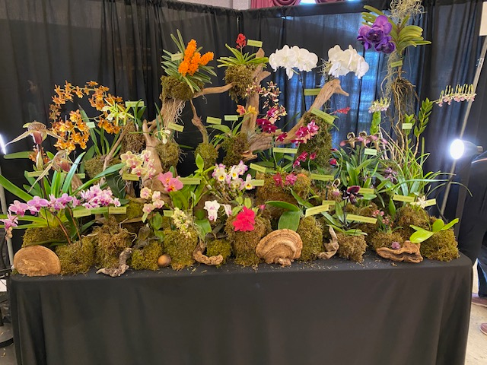

**Before ribbon judging & after ribbon judging**

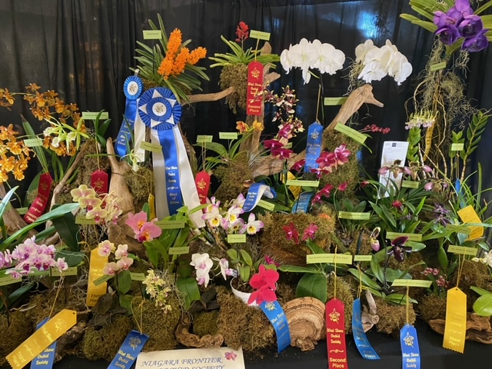

**Here is the list of guided walks in WNY**

**Native orchids are some of the plants you will see**

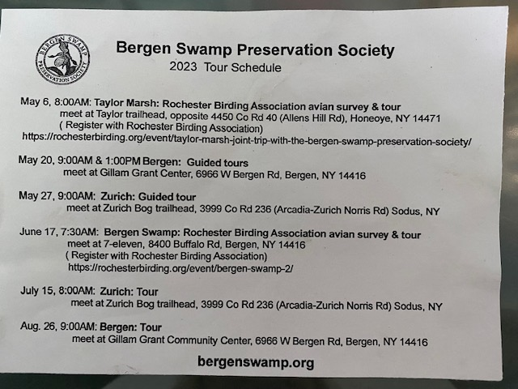

2023 Orchid Shows

Jan 13-15 Tamiami Miami

Feb 4-5 GCOS Cleveland

March 3-5 NFOS Buffalo NY

Mar 31-Ap 2 GROS Rochester NY

April 21-23 WSOS Strongsville OH

April 21-23 STOS Binghamton NY

May 19-21 Redlands Homestead FL

August 25-27 OVOF Dayton OH **

Oct 28-29 COOS Columbus OH

Nov 12-13 NFOS Buffalo NY

**Shows we travel to and do a club display sign up at the meeting.**

**\*\*Bench show**

NFOS Board Members

President: Donna Lipowicz

Vice President: Sue Charles

Treasurer: Laurie Joyce

Corresponding Sec: Cynthia Robinson

Recording Sec: Jim Gibbons

Sunshine Chair: Barb Domagala

Hospitality Dir: Betsy Kusmierski

Webmaster: Dawn Conwell (2023)

Newsletter: (2023)

At large members; Jim G, Sue L, Peter M, Russ M, Fred P, Tom P, Karen M, Betsy K, Bob H, Dawn C,

Cyndi R, Barb D, Laurie J.

**NFOS 2023 Calendar**

**Jan 3rd How we grow orchids in Buffalo**

**Feb 7th  Tour of Huntington’s Orchid Collection**

**Mar 3-5 NFOS Spring Show + night hrs**

**Mar 7th No Monthly Meeting**

**April 4th Mounting orchids $10**

**April 13th Repotting event BG 5-8pm admin bldg.**

**May 9th Ron McHattan speaker**

**May 25th Repotting event at BG 5-8pm**

**June 6th Plant Swap/How to pack blooming plants**

**July**  **No monthly mtg**

**Aug No monthly mtg Picnic Sunday 8/13/23**

**Sept 5th Webinar**

**Sept Repotting Event**

**Oct 3rd Fred Clarke speaker**

**Nov 7th Show Prep**

**Nov 10-12 NFOS Fall Show Admin bldg.**

**Dec 5th Holiday Party**