NFOS Newsletter June 2024

Tuesday June 4th, 2024 6 PM

Members Sales

Bring in your plants, books, orchid items, lights etc, along with cash to buy some excellent orchids for sale!!

Presidents Message

I hope everyone has enjoyed the hands on activities of the past couple of months. We have appreciated the additional help to repot things in the collection, and we have more that need to be repotted too. On Saturday June 22nd 12-2pm NFOS will host another repotting session for the public at the gardens, we will need volunteers to assist in this fund raiser for NFOS. We will sell our media products and repot for the public, this has been well attended in the past. Depending on how busy or if folks can stay later we may also repot some of the collection.

We historically never meet in July but this year I’m curious to see if members would still like to meet for more hands on activities, this will come up on Tuesday at the meeting to see the interest. The gardens Art sale is the last weekend in June 29-30. We have been attending and selling products & repotting orchids. We talk to people, consult with them, offer membership materials, and enjoy the garden art. Food trucks are always great, so volunteers are needed to man our booth for the weekend sign up will be available at the meeting.

Donna Lipowicz

President

GROS Show April26-28, 2024

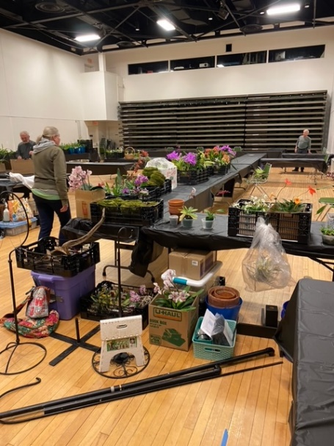 The mess we started with

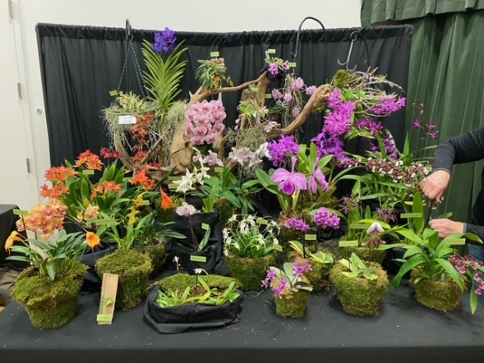 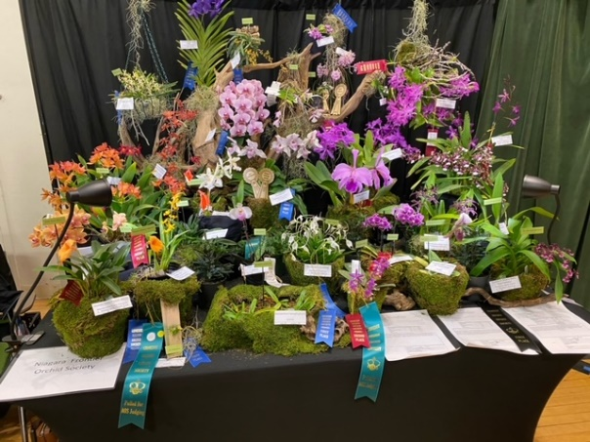

Finished set up What it looked like after judging

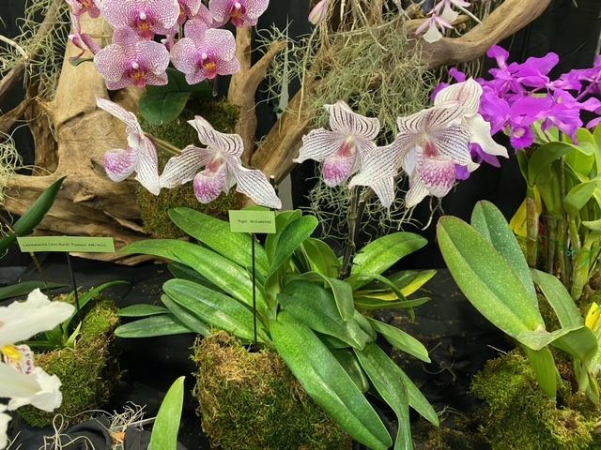 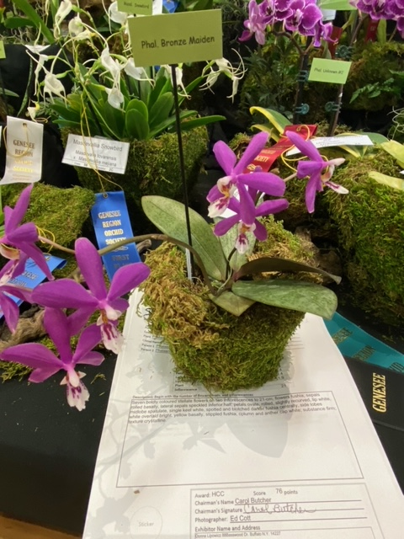

Paph Woluwnse AM/CCM AOS Phal. Bronze Maiden HCC/AOS

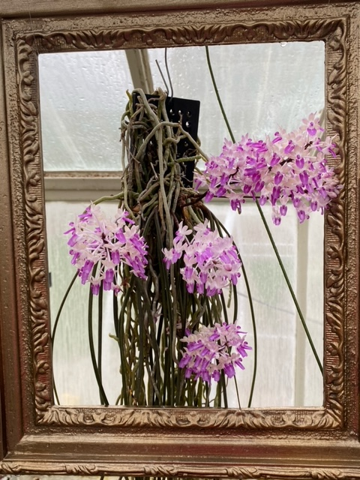

Seidenfadenia mitrata

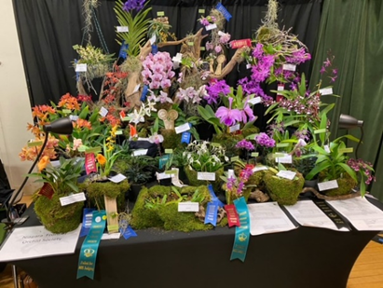

Basic breakdown of some common orchids & PPFD light ranges.

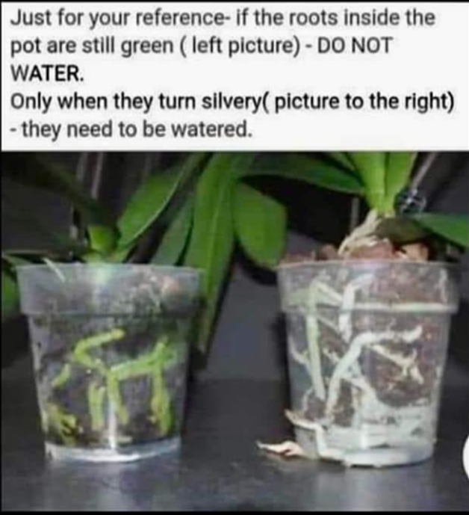

Niagara Frontier Orchid Society

Annual Picnic

Sunday August 11th 2PM

Elma Meadows Park Shelter #1

Orchid Society Will Provide Hot Dogs

Burgers, Water & Soda

Please Bring A Dish to Pass or Dessert

Electric Available Eating @ 4PM

Elma Meadows Located at 1711 Girdle Road 14059

Bring a Chair if Possible

MESSAGE FROM THE AMERICAN ORCHID SOCIETY PRESIDENT

Hello to all, and welcome to any new societies out there. We at the AOS, have been very busy with the launch of our new website, AOS.org. You all should check it out. Please report any glitches (everyone has those in something this new) to our office.

I just returned from Redland International Orchid Show where for three days straight we saw thousands of people in 106 degree heat. They still bought and bought!! Maybe some of you were there. Incredible sight. I have to admit that I shopped too….bought way too many.

I would personally like to encourage your members to join the AOS if they are not members. We have so many benefits, like the webinars, Orchid Pro, our orchid encyclopedia, new culture sheets, QR scannable codes for your shows, new pages online for culture questions. I personally would like to know why some are not members of the AOS. I invite you to tell me at cerins@aos.org. I will reply to them if I can answer any questions. AND we have a surprise coming for all affiliate reps that we will be promoting very shortly.

Stay tuned!!! – Cheryl Erins

NFOS Membership Form

Name: ____________________________

____________________________

Address: __________________________

__________________________

__________________________

Phone: ____________________________

Email_____________________________

_____________________________

Individual $15 _____

Family $20 ________

Make checks payable to NFOS

Mail to Laurie Joyce

33 Gates Circle 2D

Buffalo, NY 14209

2024 Orchid Shows

Jan 18-Mar 3 Orchid Exhibit Buffalo

Feb 4-5 GCOS Cleveland

March 1-3 NFOS Buffalo NY

April 25-28 GROS Rochester NY

April 26-28 WSOS Strongsville OH

April 20-21 STOS Binghamton NY

May 17-19 Redlands Homestead FL

August 23-25 OVOF Dayton OH **

Oct 26-27 COOS Columbus OH

Nov 8-10 NFOS Buffalo NY

**Shows we travel to and do a club display sign up at the meeting.**

**Shows in black we do not display at.**

**\*\*Bench show**

NFOS Board Members

President: Donna Lipowicz

Vice President: Sue Charles

Treasurer: Laurie Joyce

Corresponding Sec: Cynthia Robinson

Recording Sec: Jim Gibbons

Sunshine Chair: Barb Domagala

Hospitality Dir: Betsy Kusmierski

Webmaster: Dawn Conwell

Newsletter: Donna

At large members; Jim G, Peter M, Russ M, Fred P, Karen M, Betsy K, Bob H, Dawn C,

Cyndi R, Barb D, Laurie J, Sue C,

**NFOS 2024 Calendar**

**Jan 9thFind out what’s happening at the Gardens**

**Feb 6th Find out what’s happening at the gardens**

**Mar 1-3 NFOS Spring Show + night hrs in greenhouses**

**Mar 5th No Monthly Meeting**

**April 9thPotting up Phal seedlings**

**May 7th Repotting orchids Hands on workshop**

**June 4th  Members sales night**

**June 22 Repotting for the public at gardens 12-2**

**June 29/30 Garden Art Sale at BG**

**July 9**  **Possible mtg**

**Aug 11 NFOS Picnic Elma Meadows**

**Sept 3rdMark Mortenson gardens update**

**Oct 8th Eric Sauer speaker**

**Nov 5th Show Prep**

**Nov 8-10 NFOS Fall Show in Greenhouses**

**Dec 3rd Holiday Party Ilio DiPaolo’s**