NFOS Newsletter Nov 2023

Tuesday Nov 7th 2023 6 PM

Plant Registration bring your list

Show prep, Bagging Supplies

We need you please come support your society & join the fun.

Presidents Message

It’s hard to believe it’s almost show time then come the holidays and 2023 comes to an end already. NFOS continues to remain one of the busiest orchid societies I know, and I know quite a few societies due to MAOC friends. I hope some of you were able to listen to the Dr. Harold Koopowitz talk sponsored by MAOC on Oct 15th. NFOS visited the Bflo Zoo in October to consult with them on orchids for a couple different areas. Our friends Lili & Larry from Bergen also came with us as they will be a good vendor to obtain plants from. Our display at Graycliff was well received and we are awaiting a donation for our Society from their admissions.

NFOS has just received a $400 grant from MAOC to add to our Victorian orchid collection at the gardens.

We continue to consult with the Horticulture team at the gardens regarding the Jan-March Orchid Extravaganza by accessing orchids in bulk numbers from different vendors and sponsors. We will assist gardens staff with installing large orchid displays in several houses throughout the greenhouse. This several week display will end the first weekend of March which is our Spring show including after dark hours.

The collection is doing well in the new greenhouse and things are looking good. We are expanding our display all through house nine at the gardens if you haven’t been through recently it is looking quite nice. We have moved several large specimen plants on both benches and will be working on large labels for the public. Cataloging of the collection continues and we are up to 800 plants logged.

Donna Lipowicz

Orchids at Graycliff

9/28/23-10/10/23

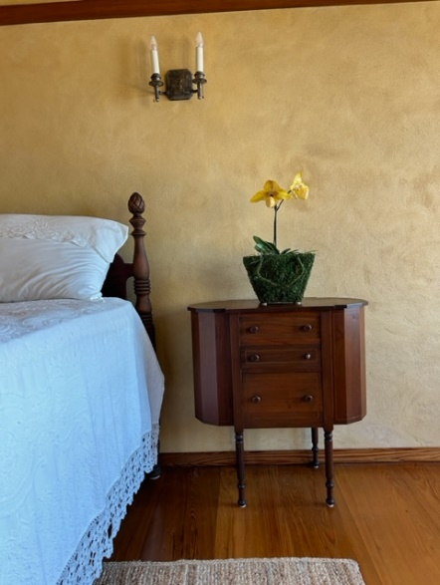 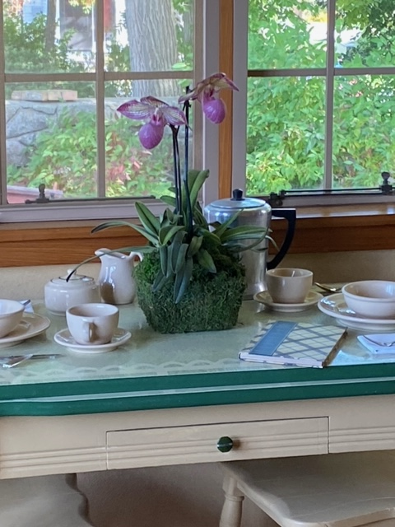 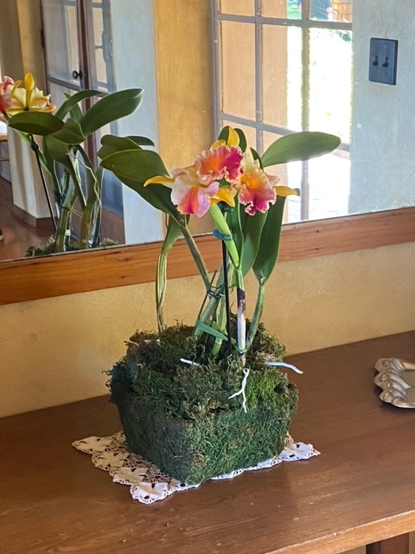

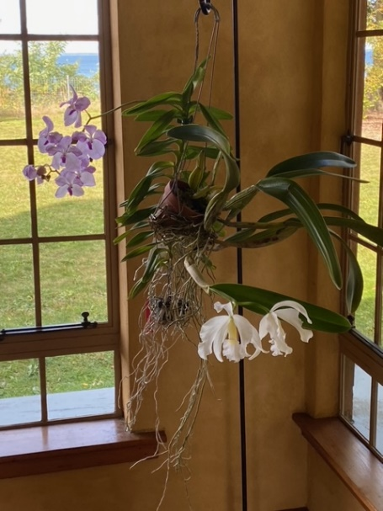 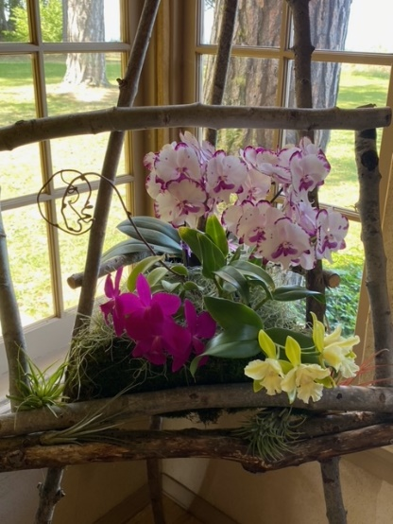 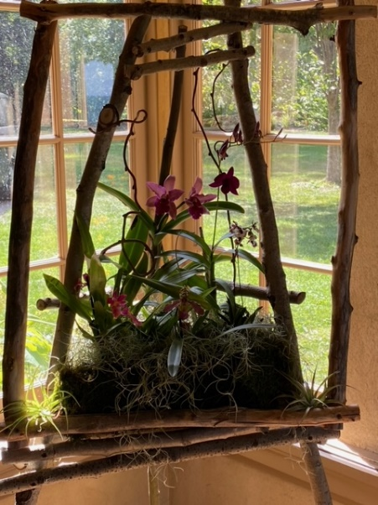

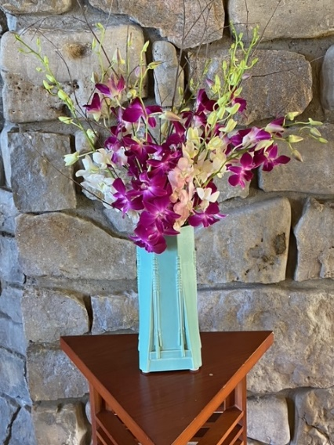 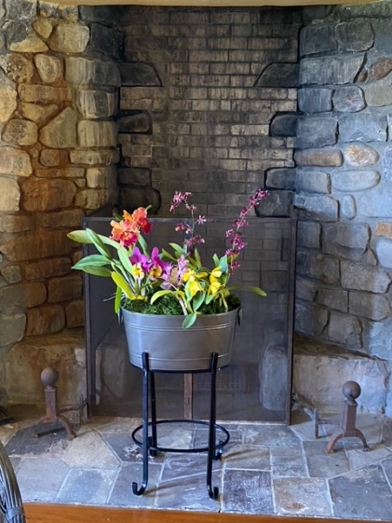 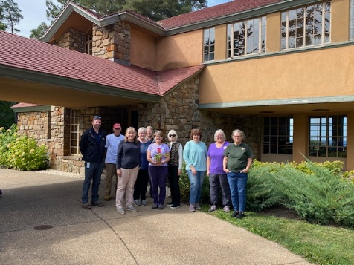

**Check for sign ups at the November meeting**

**November Show Food**

**Clerks for ribbon judging**

**I need a couple more clerks!!**

**Xmas Dinner at Ilio DiPaulo’s**

**Last chance to reserve a seat for xmas $30 per person**

**Checks can be made out to NFOS please see Laurie**

**NFOS Orchid Show Nov 11-12**

We need blooming plants for the show

NFOS website has all the plant registration information.

Dawn will assist with registration on Nov 7th

Fill out the plant registration form with name and parents if a hybrid.

2023 Orchid Shows

Jan 13-15 Tamiami Miami

Feb 4-5 GCOS Cleveland

March 3-5 NFOS Buffalo NY

Mar 31-Ap 2 GROS Rochester NY

April 21-23 WSOS Strongsville OH

April 21-23 STOS Binghamton NY

May 19-21 Redlands Homestead FL

August 25-27 OVOF Dayton OH **

Oct 28-29 COOS Columbus OH

Nov 12-13 NFOS Buffalo NY

**Shows we travel to and do a club display sign up at the meeting.**

**\*\*Bench show**

NFOS Board Members

President: Donna Lipowicz

Vice President: Sue Charles

Treasurer: Laurie Joyce

Corresponding Sec: Cynthia Robinson

Recording Sec: Jim Gibbons

Sunshine Chair: Barb Domagala

Hospitality Dir: Betsy Kusmierski

Webmaster: Dawn Conwell

Newsletter: Donna

At large members; Jim G, Sue L, Peter M, Russ M, Fred P, Tom P, Karen M, Betsy K, Bob H, Dawn C,

Cyndi R, Barb D, Laurie J, Sue C,

**NFOS 2023 Calendar**

**Jan 3rd How we grow orchids in Buffalo**

**Feb 7th  Tour of Huntington’s Orchid Collection**

**Mar 3-5 NFOS Spring Show + night hrs**

**Mar 7th No Monthly Meeting**

**April 4th Mounting orchids $10**

**April 13th Repotting event BG 5-8pm admin bldg.**

**May 9th Ron McHattan speaker**

**May 25th Repotting event at BG 5-8pm**

**June 6th Plant Swap**

**July**  **No monthly mtg**

**Aug No monthly mtg Picnic Sunday 8/13/23**

**Sept 5th Glen Sobola- Orchid Registration**

**Sept 16th Orchid Repotting 12-2pm at BG**

**Sept 27-Oct 11 Graycliff Exhibit by NFOS**

**Oct 10th Fred Clarke speaker**

**Nov 7th Show Prep**

**Nov 10-12 NFOS Fall Show Admin bldg.**

**Dec 5th Holiday Party Ilio DiPaolo’s**