NFOS Newsletter Oct 2024

Tuesday Oct 8, 2024 6 PM

We will get a gardens update &

Eric Sauer will be here to speak to us on Maxillaria, yes he will have plants for sale.

Presidents Message

It is with an another extremely heavy heart that I must inform you that The Gardens has lost Mark Mortenson CEO in September. He will be greatly missed NFOS was asked to arrange some orchid displays for his service & we were honored to do so. Our fall show is next month so please review the sign ups for clerking, food, displays, helping vendors, sales table, membership table ect…

Eric Sauer our speaker for October is the current President of Mid America Orchid Congress, President of Miami Valley Orchid Society, host of Ohio Valley Orchid Fest, owner of River Valley Orchids and Maxillariologist. This is his first trip doing the New York shuffle from Albany to Buffalo so we need to show him a warm welcome from the city of good neighbors.

The gardens are undergoing some construction of heating elements and bench removal. The orchids have moved to the begonia room during construction. We are babysitting several hundred no name phals in the garage hoping to get them to bloom for the 2025 exhibit.

Our first field trip is this Thursday Oct 3rd. Bob Hartman was kind enough to set this day up. Off to Green Circle Growers in Oberlin Ohio. We will tour their growing facility with their orchid expert as the guide. Thanks to our Ohio orchid friends for turning us on to this activity. We will report at the meeting on Tuesday Oct 8.

Donna Lipowicz

President

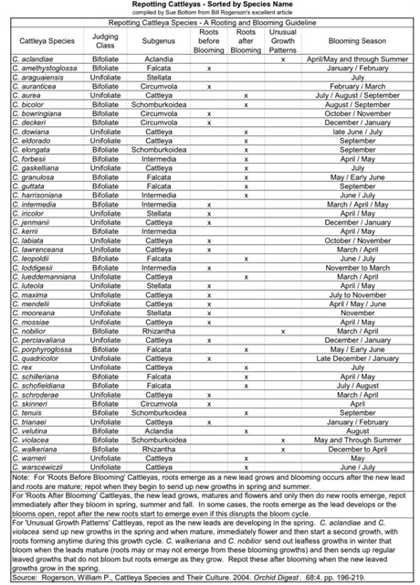

Basic breakdown of some common orchids & PPFD light ranges.

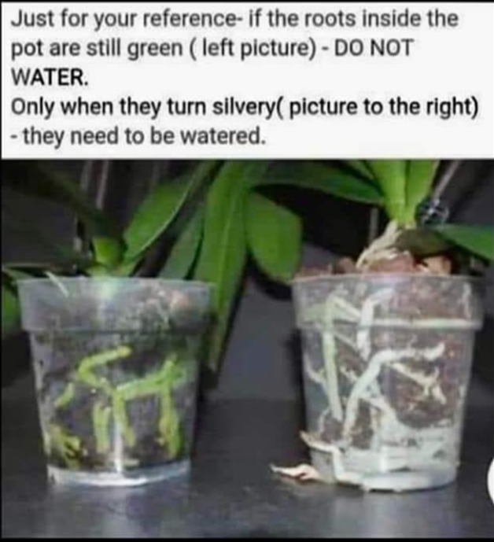

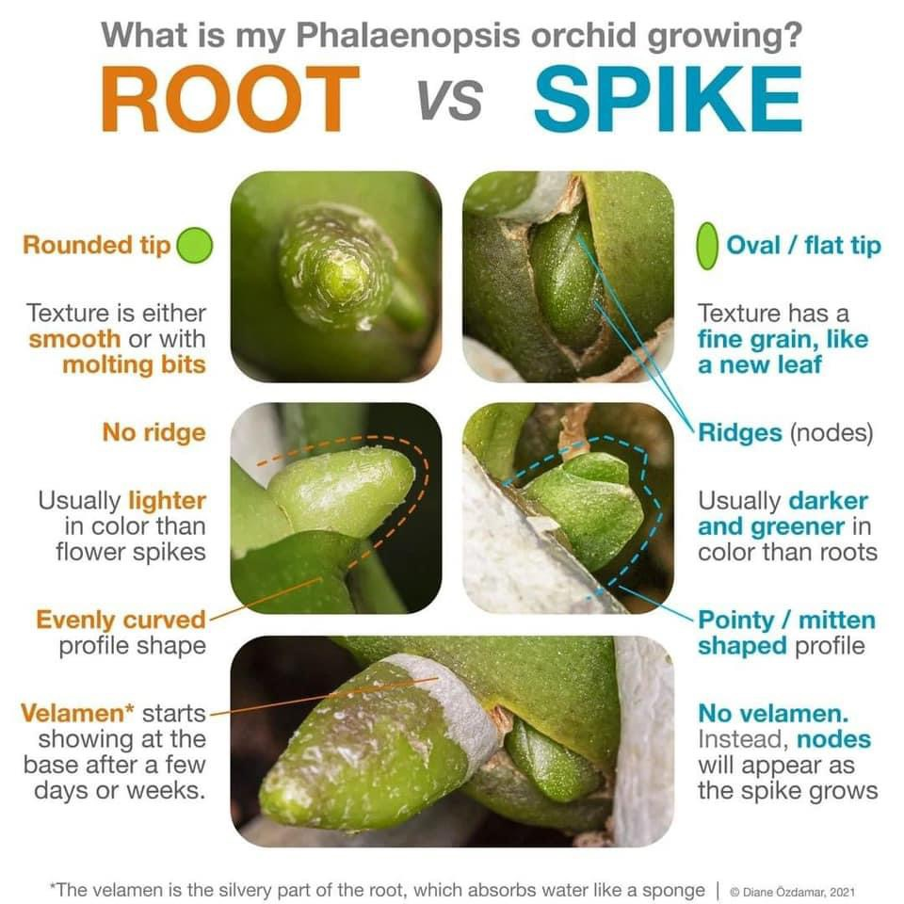

2024 Orchid Shows

Jan 18-Mar 3 Orchid Exhibit Buffalo

Feb 4-5 GCOS Cleveland

March 1-3 NFOS Buffalo NY

April 25-28 GROS Rochester NY

April 26-28 WSOS Strongsville OH

April 20-21 STOS Binghamton NY

May 17-19 Redlands Homestead FL

August 23-25 OVOF Dayton OH **

Oct 26-27 COOS Columbus OH

Nov 8-10 NFOS Buffalo NY

**Shows we travel to and do a club display sign up at the meeting.**

**Shows in black we do not display at.**

**\*\*Bench show**

NFOS Board Members

President: Donna Lipowicz

Vice President: Sue Charles

Treasurer: Laurie Joyce

Corresponding Sec: Cynthia Robinson

Recording Sec: Jim Gibbons

Sunshine Chair: Barb Domagala

Hospitality Dir: Betsy Kusmierski

Webmaster: Dawn Conwell

Newsletter: Donna

At large members; Jim G, Peter M, Russ M, Fred P, Karen M, Betsy K, Bob H, Dawn C, Cyndi R, Barb D, Laurie J, Sue C,

**NFOS 2024 Calendar**

**Jan 9thFind out what’s happening at the Gardens**

**Feb 6th Find out what’s happening at the gardens**

**Mar 1-3 NFOS Spring Show + night hrs in greenhouses**

**Mar 5th No Monthly Meeting**

**April 9thPotting up Phal seedlings**

**May 7th Repotting orchids Hands on workshop**

**June 4th  Members sales night**

**June 22 Repotting for the public at gardens 12-2**

**June 29/30 Garden Art Sale at BG**

**July 9**  **Repotting orchids Hands on workshop**

**Aug 11 NFOS Picnic Elma Meadows**

**Sept 10th Edgar Stehli on Habenaria’s**

**Oct 3rd Field Trip to Green Circle Growers Ohio**

**Oct 8th Eric Sauer speaking on Maxillaria’s**

**Nov 5th Show Prep**

**Nov 8-10 NFOS Fall Show in Greenhouses**

**Dec 3rd Holiday Party Pot Luck Botanical Gardens**