NFOS Newsletter Sept 2023

Tuesday Sept 5th 2023 6 PM

Guest Speaker

Glen Sobola

from

Greater Cleveland Orchid Society

“How to register your orchid for the November show”

NFOS Board meeting minutes 08/02/2023

President Donna called the August Board meeting to order on ZOOM at 8:20 PM. Present in spirit were Donna Lipowicz, Sue Charles, Laurie Joyce, Jim Gibbons, Barb Domagala, Cyndi Robinson, Bob Hartman, Dawn Conwell, and Betsy Kusmierski.

There was a discussion of the proposed NFOS display at the Erie County Fair, beginning on 08/09/2023. Set up will take place at 10:00 AM. Donna will pick up phals from Trader Joe’s, and supply a number of kokedamas for the display.

The Ohio Valley Orchid Fest will be held at the end od August. There will 12 vendors on hand, and the Fest will be indoors.

For our September 5th membership meeting, Glen Sobola, the IT expert from Cleveland will be speaking and explaining the new orchid registration rules for orchid shows. Our October membership meeting has been changed to October 10th, to match the dates that guest speaker Fred Clarke will be available for his journey across upstate New York. He will be speaking about Catasetums and Mormodes. He has developed mini-Catasetums that can bloom as many as four times a year. Donna urges the membership to get on his website to get your orders in for these plants before they’re all gone.

The NFOS has been invited by Graycliff to set up an orchid display there from 09/27/2023 through 10/11/2023. In return, Graycliff will share a portion of the entrance fees with the NFOS. Donna will be contacting Arthur Chadwick for a selection of vintage Cattleyas, to match the years (1928-1941) when Mrs. Isabelle Martin resided there. Set up day will be Wednesday 09/27/2023, when the house is closed. It was suggested that Fred Clarke be taken to Graycliff for a tour prior to our October meeting.

Donna will be seeking a financial contribution from the MAOC to build up the BECBG collection. She notes that the NFOS has received $5600 dollars from the insurance settlement the Botanical Gardens received for the December storm damage, and she has been buying orchids up a storm, to coin a phrase.

The NFOS Christmas Dinner, 12/05/2023, was discussed. If we go back to Chef’s, we will need a bigger room than last year. It was suggested that Ilio Di Paolo’s, where the monthly guest speakers are fed, be contacted, re: price, room, etc. be contacted for comparison.

Regarding the NFOS Spring Show, the BECBG wants the NFOS to maintain orchid displays in every greenhouse for six weeks, culminating in our Show on 03/24/2024. The BECBG wants to be mentioned in the same class as the large botanical garden shows in Florida, and California, and are willing to spend $10000 to $15000 in that effort. We will be seeking help from our favorite vendors and wholesalers.

The NFOS picnic is set for Sunday August 13th, in Shelter #1, at the same venue as last year.

The meeting was closed at 9:33PM.

Minutes submitted by Jim Gibbons

Niagara Frontier Orchid Society

Annual Picnic

Sunday August 13th 2PM

**Fun was had by all on a pleasant Sunday afternoon. Todd the grill master fired up some tasty vittles on the grill. As usual all of the side dishes were fabulous, and Peters cake was delicious as usual.**

**See you all again next year!**

**Check for sign ups at the Sept meeting**

**NFOS Updates**

**Mini Catasetums from Fred Clarke have arrived so the gardens will have a nice collection of them now.**

**Peter has deflasked our Phals from Carter & Holmes as well as our Chysis that we had flasked. All are in community pots at this time growing bigger, at some point in the future members will be able to purchase them & see who blooms them first!**

**We were able to find a mature blooming size Bulbophyllum phalaenopsis for the collection at the gardens. It is a conversation piece with its leaves that get up to 3 feet long and the flower scent of rotting meat that draws flies for pollination.**

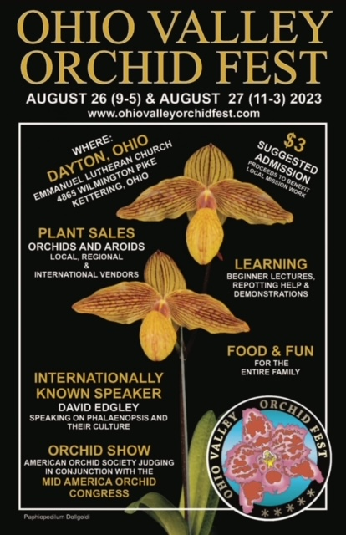

Fred, Jane, Sue and I were there we saw all of our MAOC friends, even some friends from GROS were there & ended up joining NFOS!

Peter won

Welcome Carol Butcher & Diane Bernard!

2023 Orchid Shows

Jan 13-15 Tamiami Miami

Feb 4-5 GCOS Cleveland

March 3-5 NFOS Buffalo NY

Mar 31-Ap 2 GROS Rochester NY

April 21-23 WSOS Strongsville OH

April 21-23 STOS Binghamton NY

May 19-21 Redlands Homestead FL

August 25-27 OVOF Dayton OH **

Oct 28-29 COOS Columbus OH

Nov 12-13 NFOS Buffalo NY

**Shows we travel to and do a club display sign up at the meeting.**

**\*\*Bench show**

NFOS Board Members

President: Donna Lipowicz

Vice President: Sue Charles

Treasurer: Laurie Joyce

Corresponding Sec: Cynthia Robinson

Recording Sec: Jim Gibbons

Sunshine Chair: Barb Domagala

Hospitality Dir: Betsy Kusmierski

Webmaster: Dawn Conwell (2023)

Newsletter:

At large members; Jim G, Sue L, Peter M, Russ M, Fred P, Tom P, Karen M, Betsy K, Bob H, Dawn C,

Cyndi R, Barb D, Laurie J, Sue C,

**NFOS 2023 Calendar**

**Jan 3rd How we grow orchids in Buffalo**

**Feb 7th  Tour of Huntington’s Orchid Collection**

**Mar 3-5 NFOS Spring Show + night hrs**

**Mar 7th No Monthly Meeting**

**April 4th Mounting orchids $10**

**April 13th Repotting event BG 5-8pm admin bldg.**

**May 9th Ron McHattan speaker**

**May 25th Repotting event at BG 5-8pm**

**June 6th Plant Swap**

**July**  **No monthly mtg**

**Aug No monthly mtg Picnic Sunday 8/13/23**

**Sept 5th Glen Sobola- Orchid Registration**

**Sept 16th Orchid Repotting 12-2pm at BG**

**Sept 27-Oct 11 Graycliff Exhibit by NFOS**

**Oct 10th Fred Clarke speaker**

**Nov 7th Show Prep**

**Nov 10-12 NFOS Fall Show Admin bldg.**

**Dec 5th Holiday Party Ilio DiPaolo’s**