NFOS Newsletter Sept 2024

Tuesday Sept 10, 2024 6 PM

We will get a gardens update &

Edgar Stehli will be speaking on Habenaria’s

Presidents Message

It is with an extremely heavy heart that I must inform you all that we have lost our beloved member Howard P. Martin. We were blessed to have him all of these years to teach us and mentor us with his vast knowledge of orchids. No services were planned by the family. We all have had the opportunity to obtain one or more of his gorgeous plants as he was selling off his collection. Hopefully some will be blooming in November so we can set up a memorial Peter display of his blooming plants. A group of us attended Orchid Fest a couple weeks ago in Dayton and had a great time. Peter T. Lin was the speaker and we enjoyed his talks on mini catts and Dendrobiums. Cheryl Erins AOS president was also there and spoke about her Ikea cabinets with humidity for the little orchids that live in the cloud forests.

September begins our season of regular meetings and we will learn about Habenaria’s and Maxillaria’s in next two meetings so don’t miss them.

Donna Lipowicz

President

Habenaria

Habenaria orchids are found in various regions around the world. They typically grow in tropical & subtropical areas ranging from lowland tropical forests to mountainous regions their distribution spans several continents. Africa, Madagascar, Kenya, Uganda, India Sri Lanka, Thailand, China, Japan, Vietnam, Australia, New Zealand, Papua New Guinea, Southeastern US, Mexico, Brazil, Columbia, Peru.

Habenaria Hampson Habenaria medusa

Basic breakdown of some common orchids & PPFD light ranges.

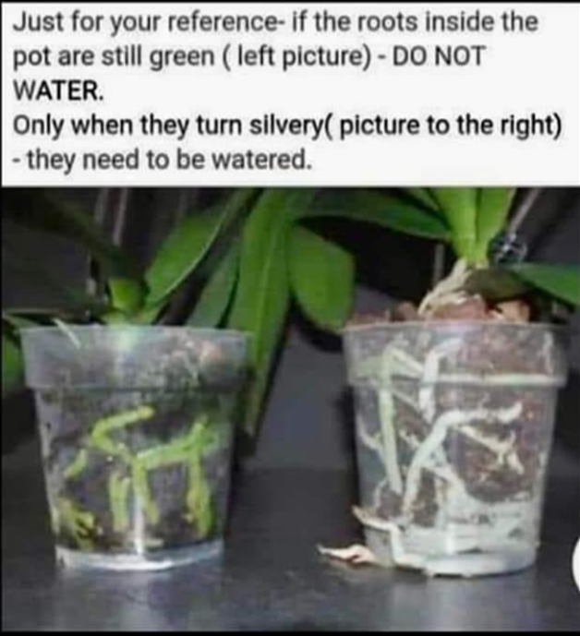

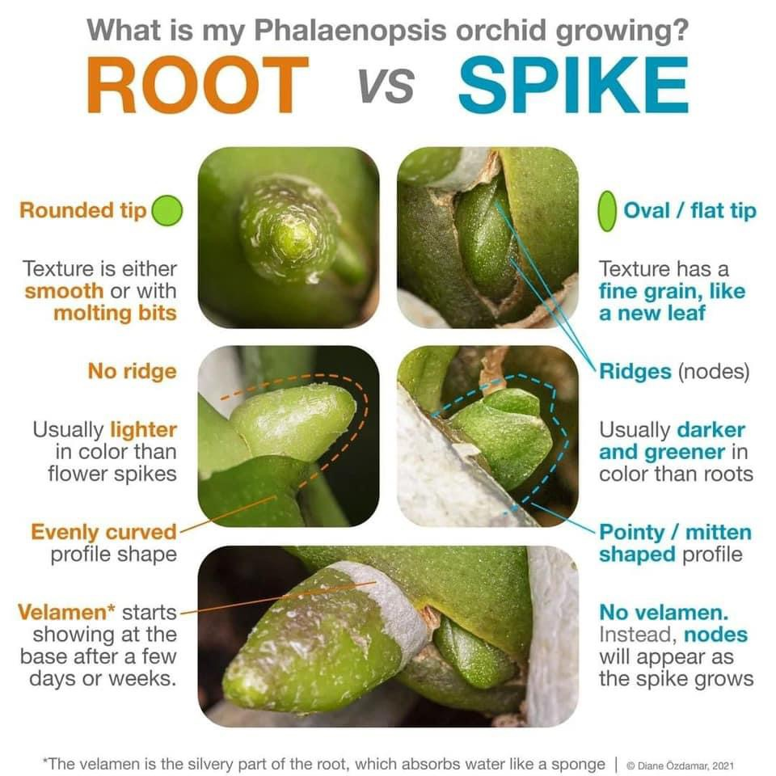

2024 Orchid Shows

Jan 18-Mar 3 Orchid Exhibit Buffalo

Feb 4-5 GCOS Cleveland

March 1-3 NFOS Buffalo NY

April 25-28 GROS Rochester NY

April 26-28 WSOS Strongsville OH

April 20-21 STOS Binghamton NY

May 17-19 Redlands Homestead FL

August 23-25 OVOF Dayton OH **

Oct 26-27 COOS Columbus OH

Nov 8-10 NFOS Buffalo NY

**Shows we travel to and do a club display sign up at the meeting.**

**Shows in black we do not display at.**

**\*\*Bench show**

NFOS Board Members

President: Donna Lipowicz

Vice President: Sue Charles

Treasurer: Laurie Joyce

Corresponding Sec: Cynthia Robinson

Recording Sec: Jim Gibbons

Sunshine Chair: Barb Domagala

Hospitality Dir: Betsy Kusmierski

Webmaster: Dawn Conwell

Newsletter: Donna

At large members; Jim G, Peter M, Russ M, Fred P, Karen M, Betsy K, Bob H, Dawn C, Cyndi R, Barb D, Laurie J, Sue C,

**NFOS 2024 Calendar**

**Jan 9thFind out what’s happening at the Gardens**

**Feb 6th Find out what’s happening at the gardens**

**Mar 1-3 NFOS Spring Show + night hrs in greenhouses**

**Mar 5th No Monthly Meeting**

**April 9thPotting up Phal seedlings**

**May 7th Repotting orchids Hands on workshop**

**June 4th  Members sales night**

**June 22 Repotting for the public at gardens 12-2**

**June 29/30 Garden Art Sale at BG**

**July 9**  **Repotting orchids Hands on workshop**

**Aug 11 NFOS Picnic Elma Meadows**

**Sept 10th Gardens update Edgar Stehli on Habenaria’s**

**Oct 8th Eric Sauer speaking on Maxillaria’s**

**Nov 5th Show Prep**

**Nov 8-10 NFOS Fall Show in Greenhouses**

**Dec 3rd Holiday Party Ilio DiPaolo’s**