# Niagara Frontier Orchid Society

‘Orchid’s Under Glass’

November 9-10, 2024

Orchid Displays

American Orchid Society Judging

Awards

Orchid Vendors

Orchid Supplies

Orchid Art/Pottery

Orchid Jewelry

At the Buffalo and Erie Co. Botanical Gardens

2655 South Park Ave.,

Buffalo, New York 14218

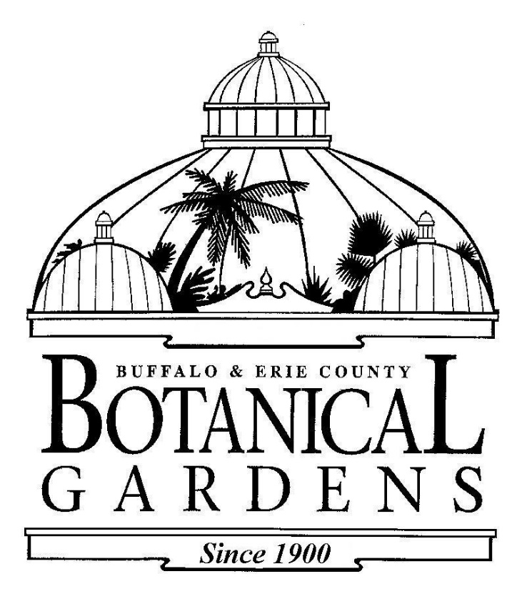

* * * * * * * * * * * * * * * * * * * * * * * * * * * * * * * * * * * * * * * * * * * * * *

## 

## Email plant registration forms to

To: Dawn Conwell NFOS Show Registrar

E-Mail: [dawn.conwell@comcast.net](mailto:dawn.conwell@comcast.net)

Sue Charles NFOS Show Chair NFOS Vice President

Email: [scc1959@verizon.net](mailto:scc1959@verizon.net)

Donna Lipowicz, President NFOS

716-479-7698 E-mail: [ladysliper@roadrunner.com](mailto:ladysliper@roadrunner.com)

* * * * * * * * * * * * * * * * * * * * * * * * * * * * * * * * * * * * * * * * * * * * * **

Website: http://www.niagarafrontierorchids.org/

**NFOS Show Rules and Regulations:**

1. Set up is Friday, November 8th from 12:00 PM until 6:00 PM. Exhibits will be displayed throughout the conservatory. All plants & exhibits must be registered by 6:00 PM. **Email registrations must be in by Thursday 11/7/24 by 8 pm.**

**We will accept last minute walk in registrations until 2 pm Friday 11/8/24.**

1. AOS Awards: This show **is** an AOS Judged show and will be judged by AOS judges.
2. Plants can be entered in more than one class. Examples: species/hybrid class and first bloom seedling.
3. All exhibitors entering classes must register the exhibit as well as the plants.
4. For the purpose of this show, an ‘amateur’ is defined as any person who has not sold more than a total of two hundred (200) plants and/or flowers in the last year.
5. Each exhibitor agrees to abide by the rules and regulations. Judge’s decisions will be final.
6. Judges will have the right to award or withhold any scheduled prize and may

sub-divide any class.

1. All questions regarding interpretation of the rules shall be referred to the Show Chair.
2. Only authorized persons are permitted in the show area during judging.
3. The Niagara Frontier Orchid Society will take precautions for the safety of the exhibits but will not be responsible for loss or damage.
4. Orchids are to be the only flowering plants in displays.
5. Exhibitors must provide their own table covers, foliage plants and labeling.
6. The Show Committee reserves the right to limit space to any exhibitor – should space become limited.
7. The Show Chair reserves the right to judge suitability and appropriateness of any exhibit and to alter the exhibit as deems necessary.
8. The Show Chair will provide exhibit signs based on the name provided on the exhibit entry form. Exhibit names will not be visible until after the judging is complete.
9. Plants eligible for Cultural Awards must have been grown by the exhibitor for at least twelve months prior to the show.
10. There is no entry fee for plants or exhibits. AOS fees are the responsibility of those individuals receiving AOS awards.
11. All plants and displays must be in place until 3:00 PM on Sunday November 10th.
12. All plants and exhibit materials must be removed immediately after the close of the show on Sunday November 10th.
13. EACH EXHIBITOR IS RESPONSIBLE FOR CLEANING THEIR EXHIBIT AREA AFTER REMOVAL OF MATERIALS.